**Remote Patient Monitoring System (RPMS)**

**Project Report**  
**Course:** CS-212 Object-Oriented Programming  
**Semester:** Spring 2025  
**Class:** BSAI-1A  
**Instructor:** Nazia Perwaiz

**Group Members:**

Alap Gohar – 502082

Abdullah Farooq – 509528

Huma Ejaz -

**1. Project Overview**

* **Objective:**  
  The goal of RPMS is to enable remote tracking of patient vitals and facilitate communication between patients and doctors using Java-based technologies and OOP concepts.
* **Key Features:**
  + Health Data Upload via CSV
  + Doctor Feedback & Medication
  + Emergency Alert System
  + Chat/Video Consultation
  + Health Report Generation
  + Data Visualization
  + Role-Based User Management
  + Object Serialization/Deserialization for Storing/Loading data

**2. Functional Requirements Implementation (GUI Screenshots)**

**2.1. User Management**

* Role-based login and dashboards for Patients, Doctors, and Admins.

1. Login Screen (Also showing secure login/logout):

Main Screen User validation  
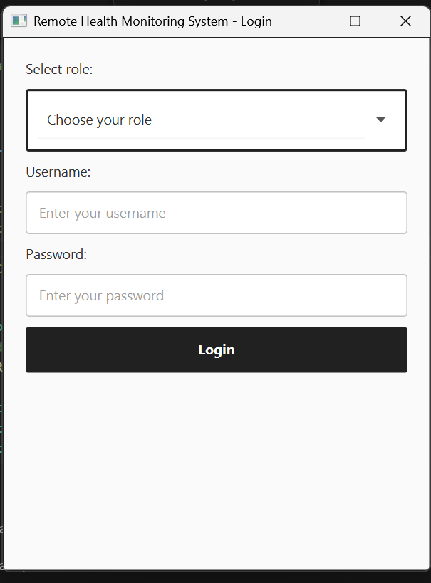 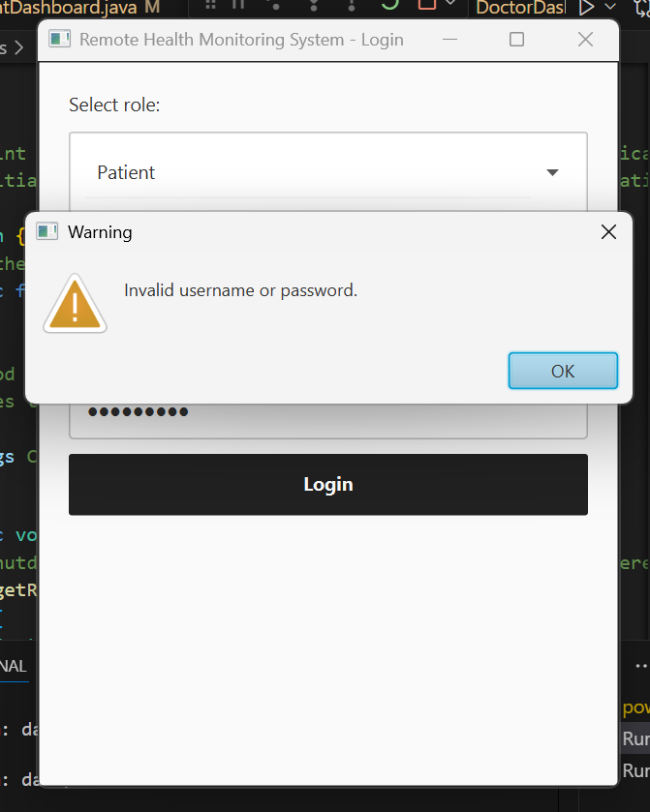 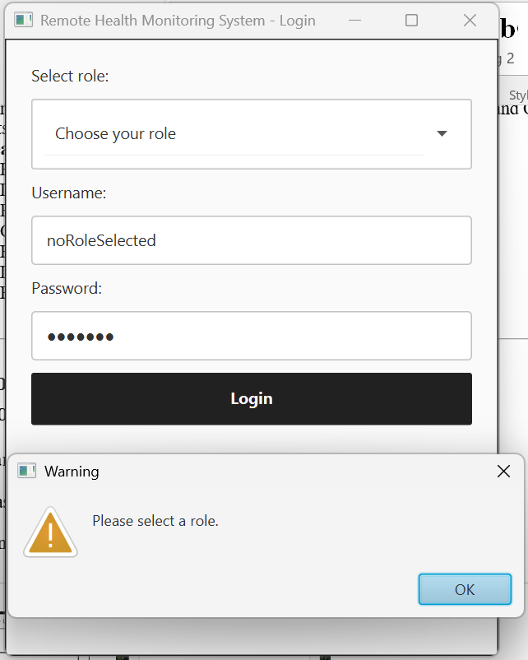

Logging out:

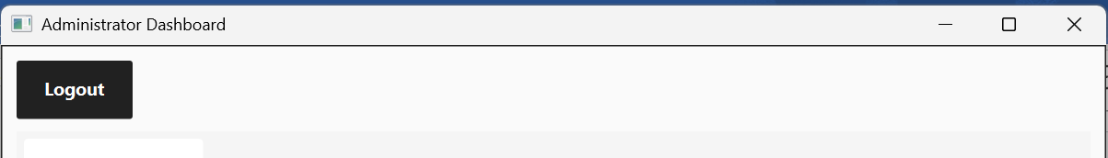

2. Role based dashboards with different functionalities

a. **Patient Dashboard** (with all different tabs and available functionalities)

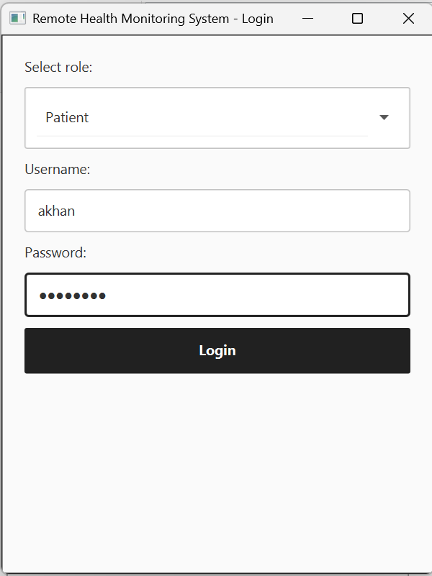

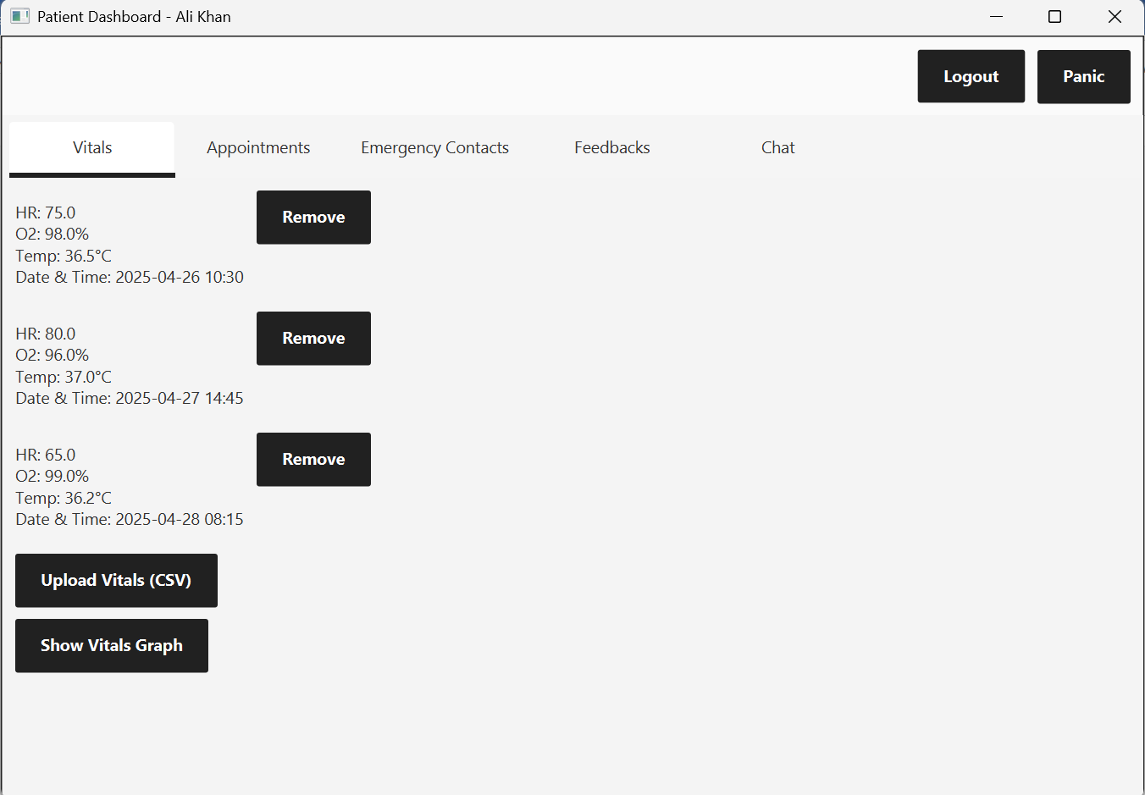

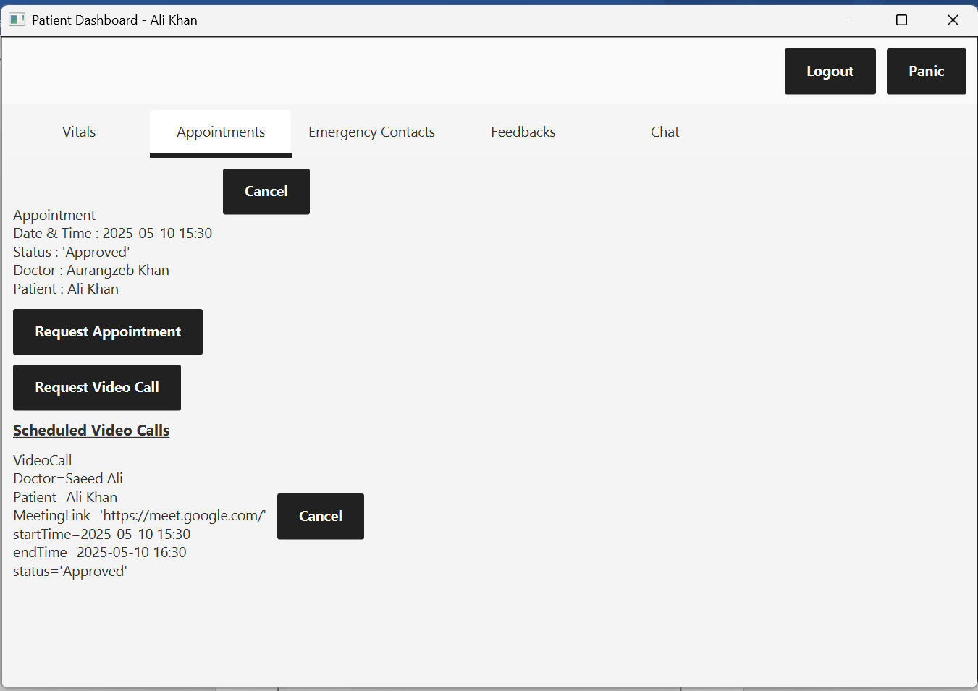

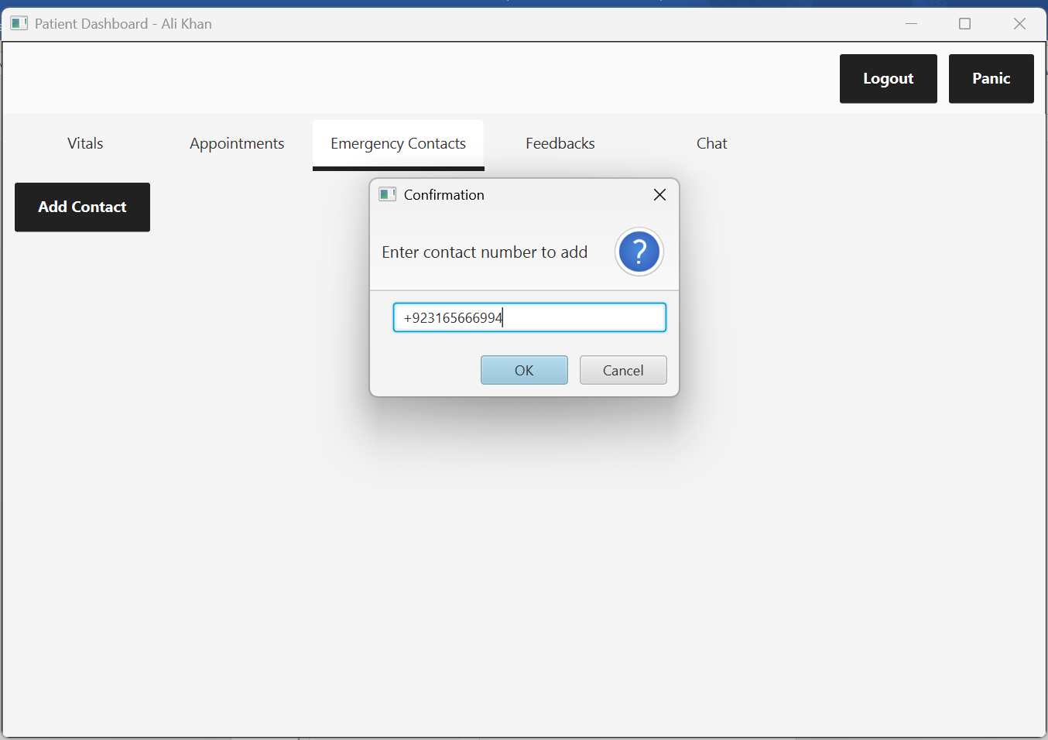

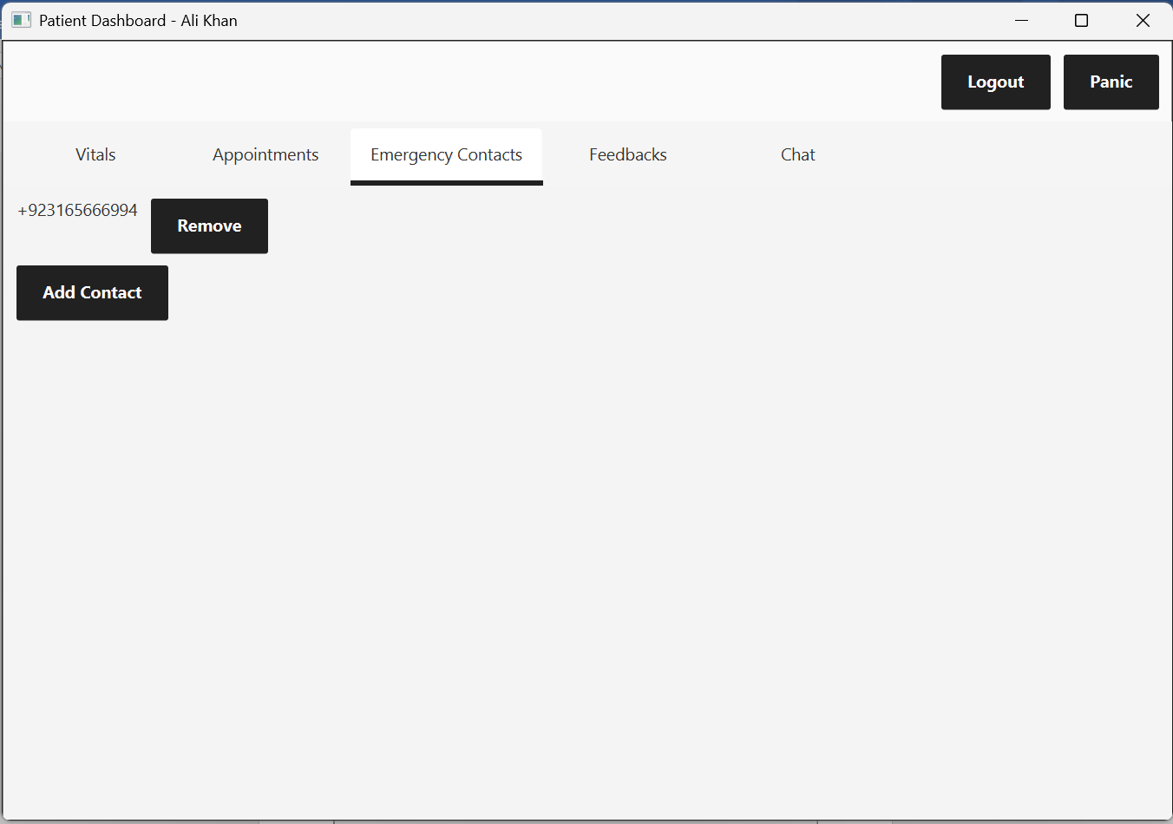

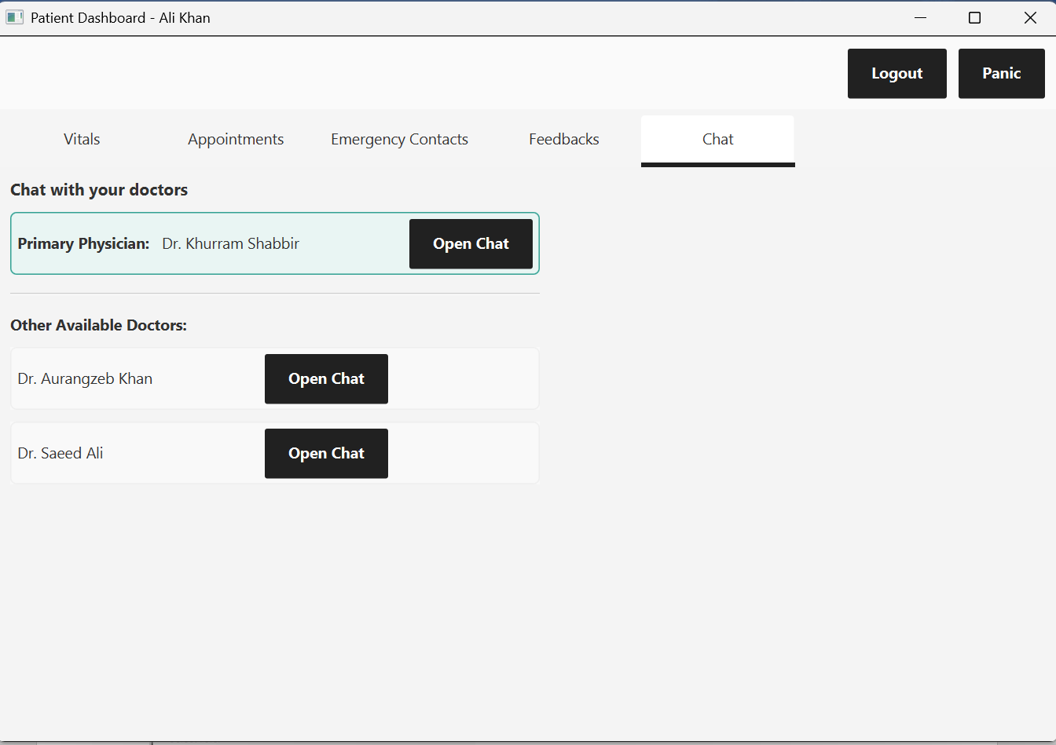

b. **Doctor Dashboard** (with all different tabs and available functionalities)

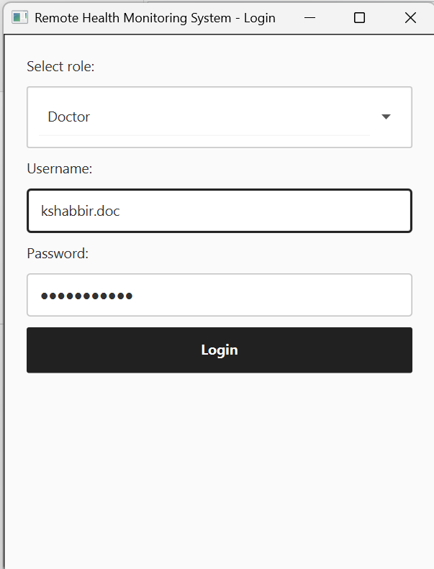

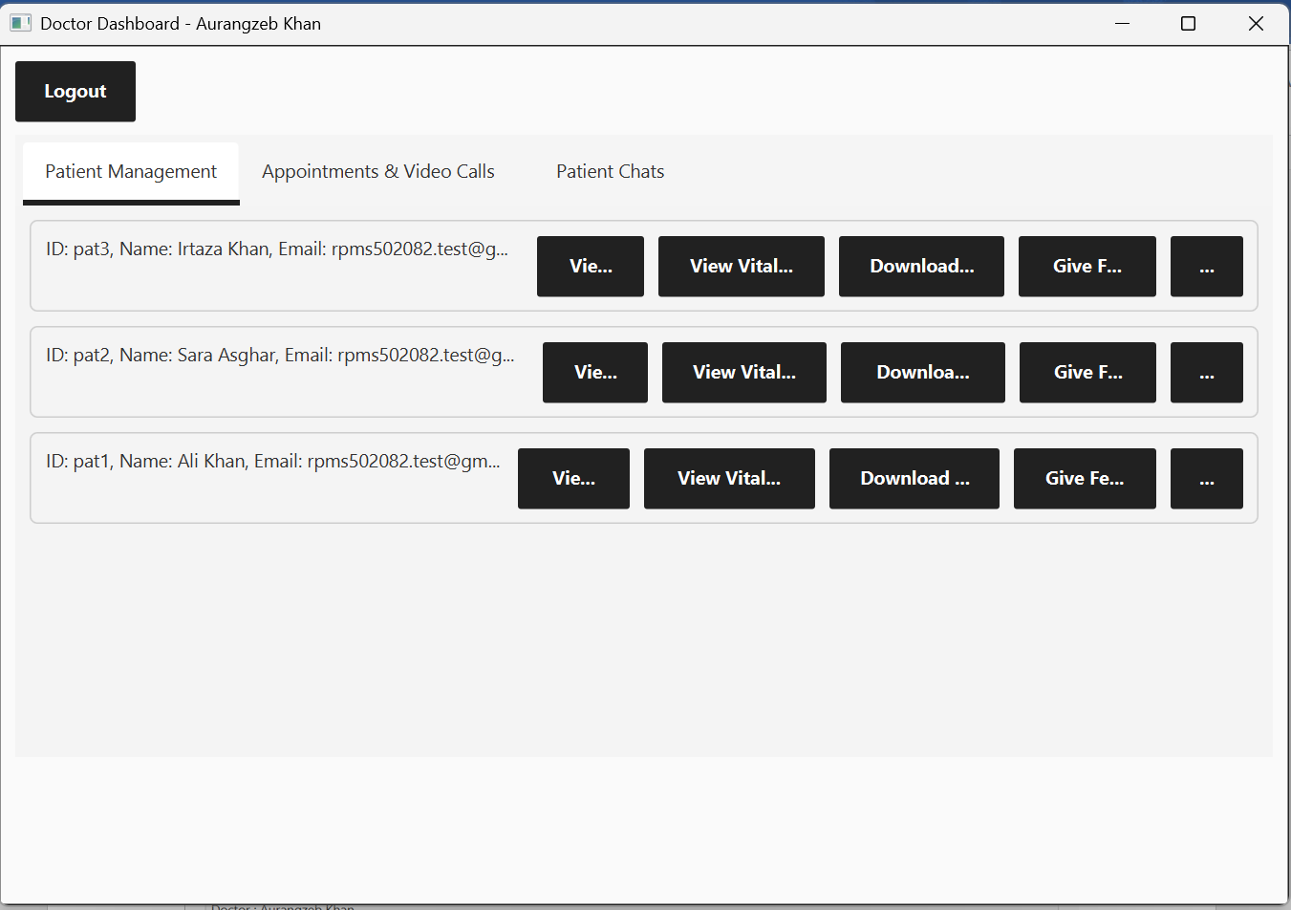

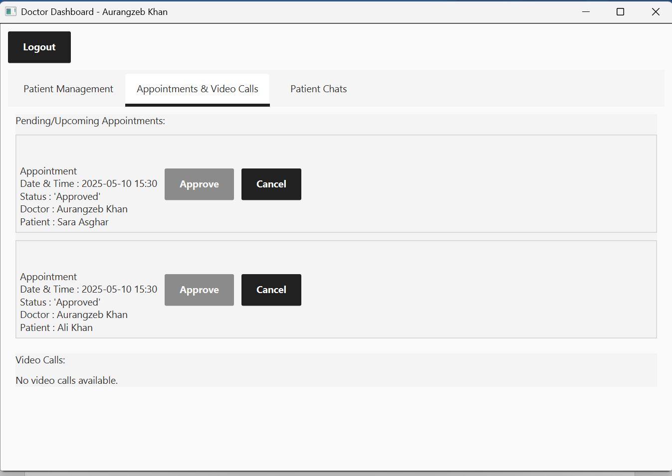

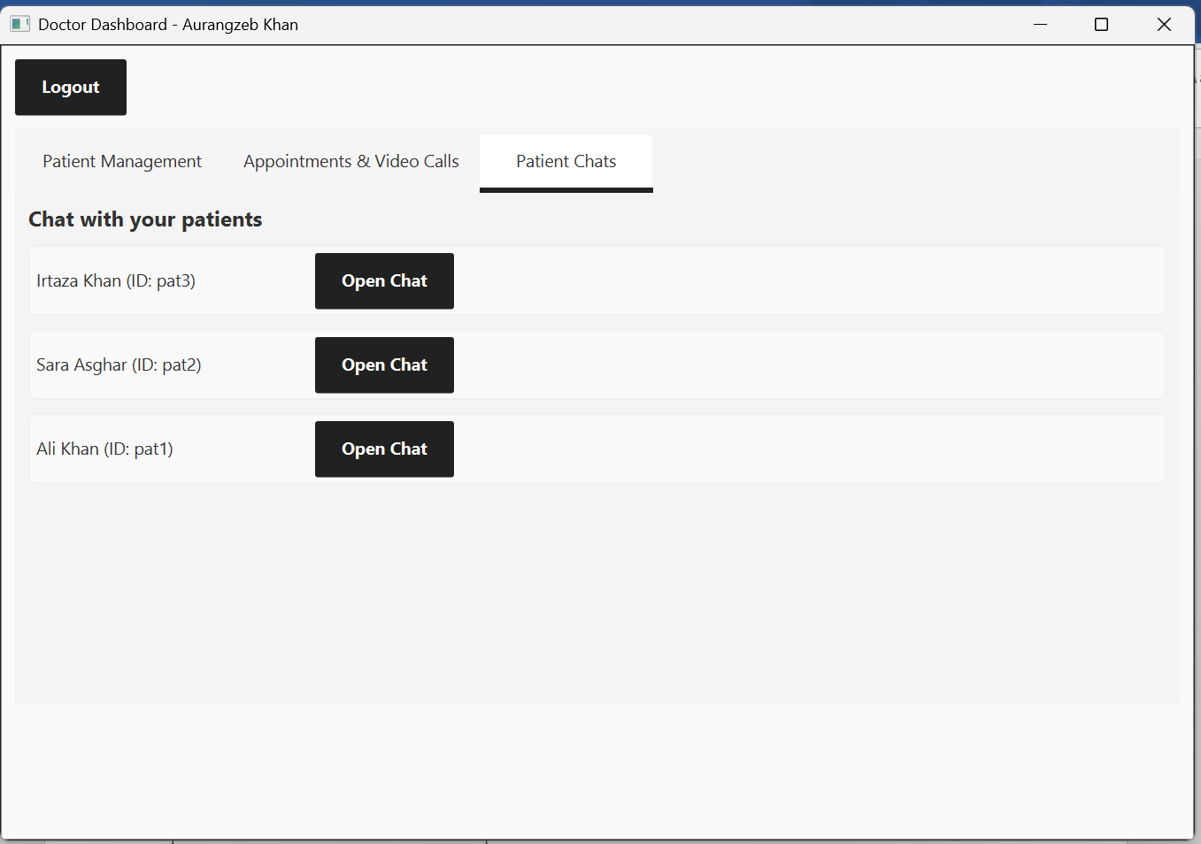

c. **Administrator Dashboard (with available buttons and functionalities)**

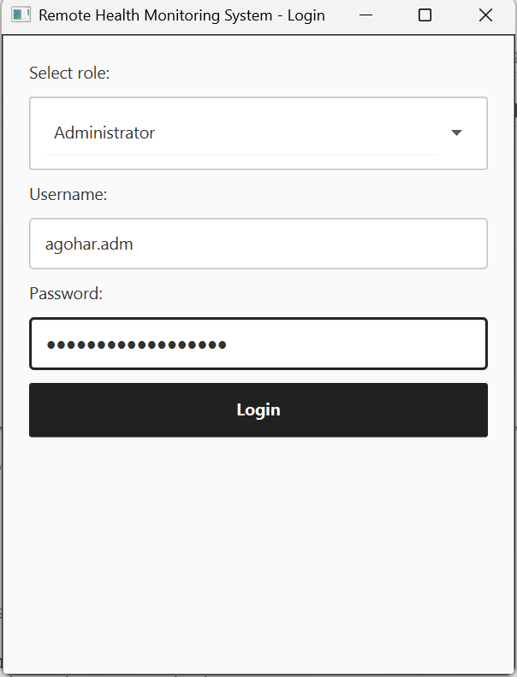

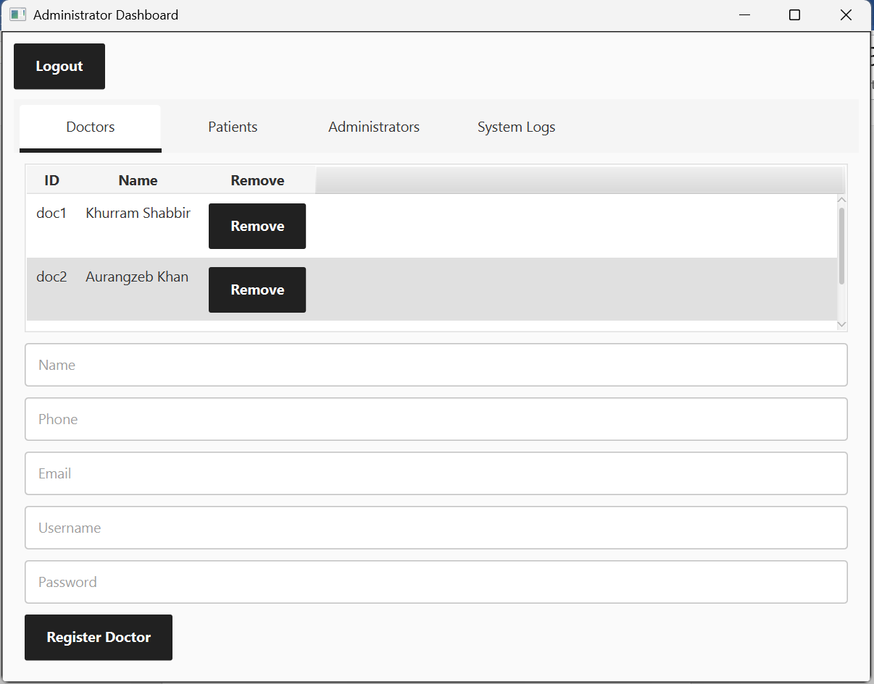

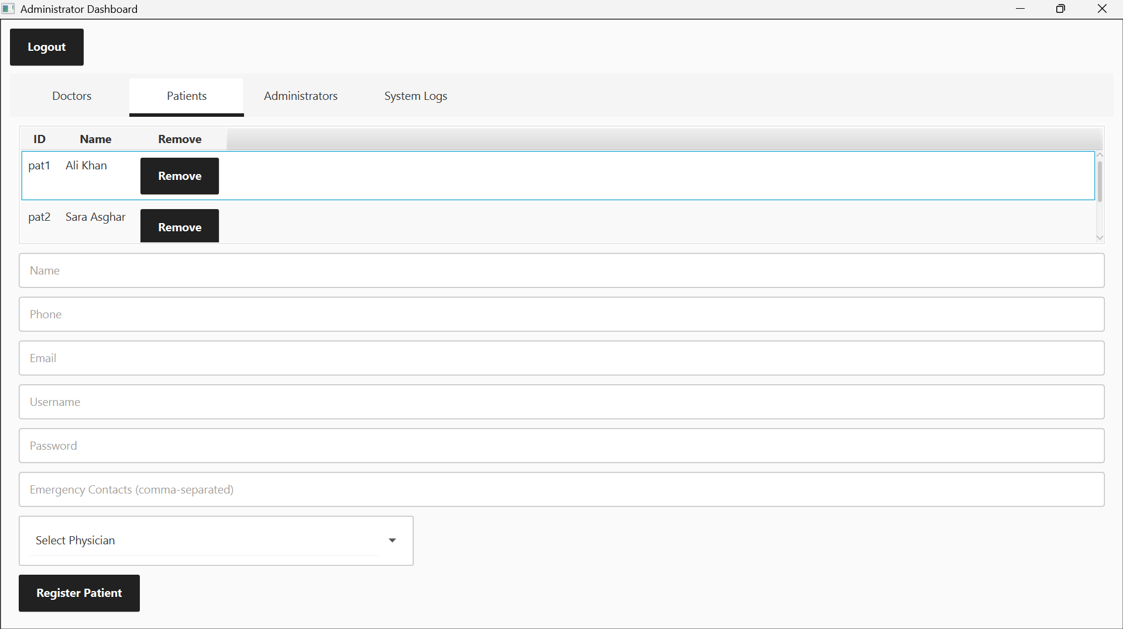

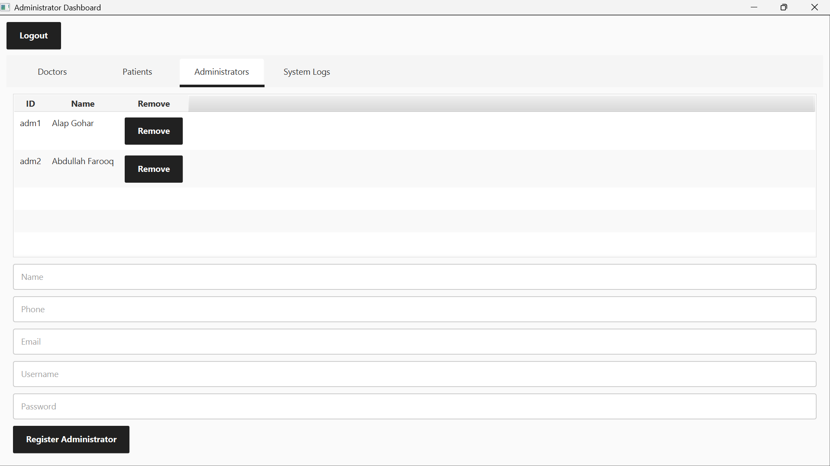

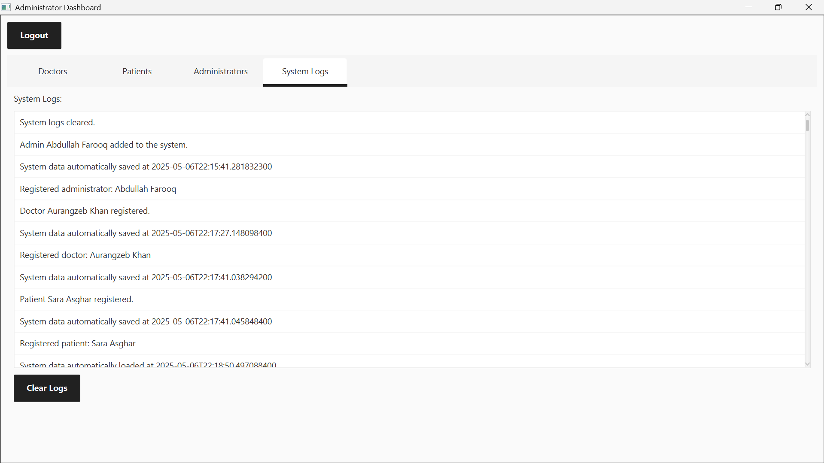

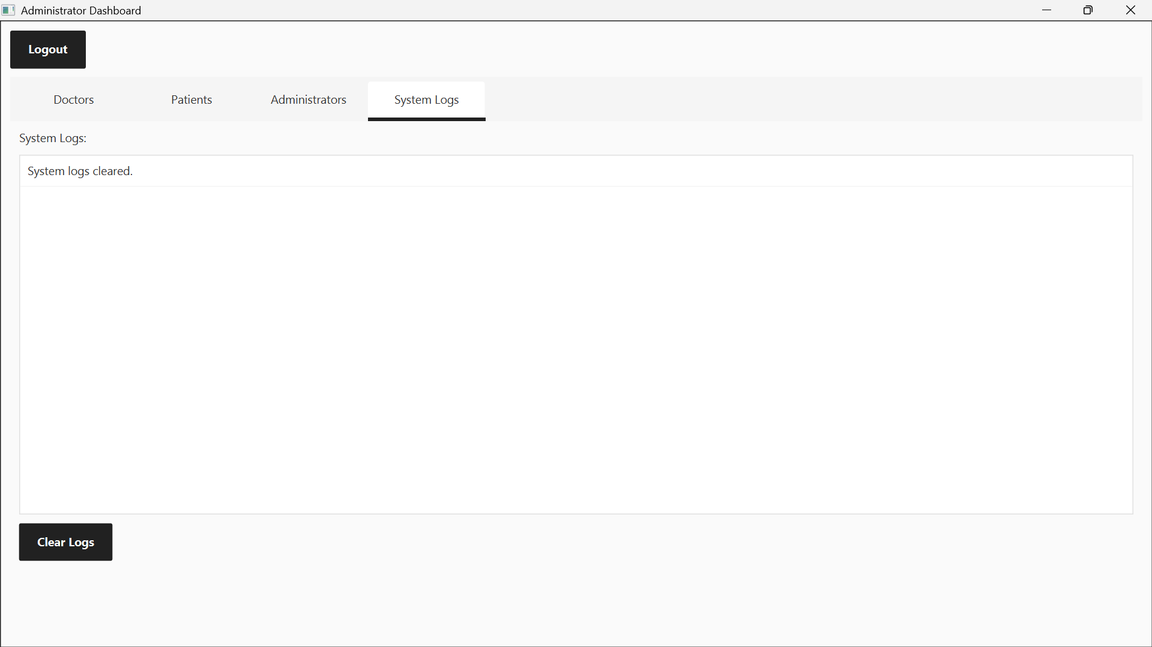

**2.2. Health Data Upload & Processing**

* Description of how patients upload vitals via CSV.

1. Login to the Patient Dashboard

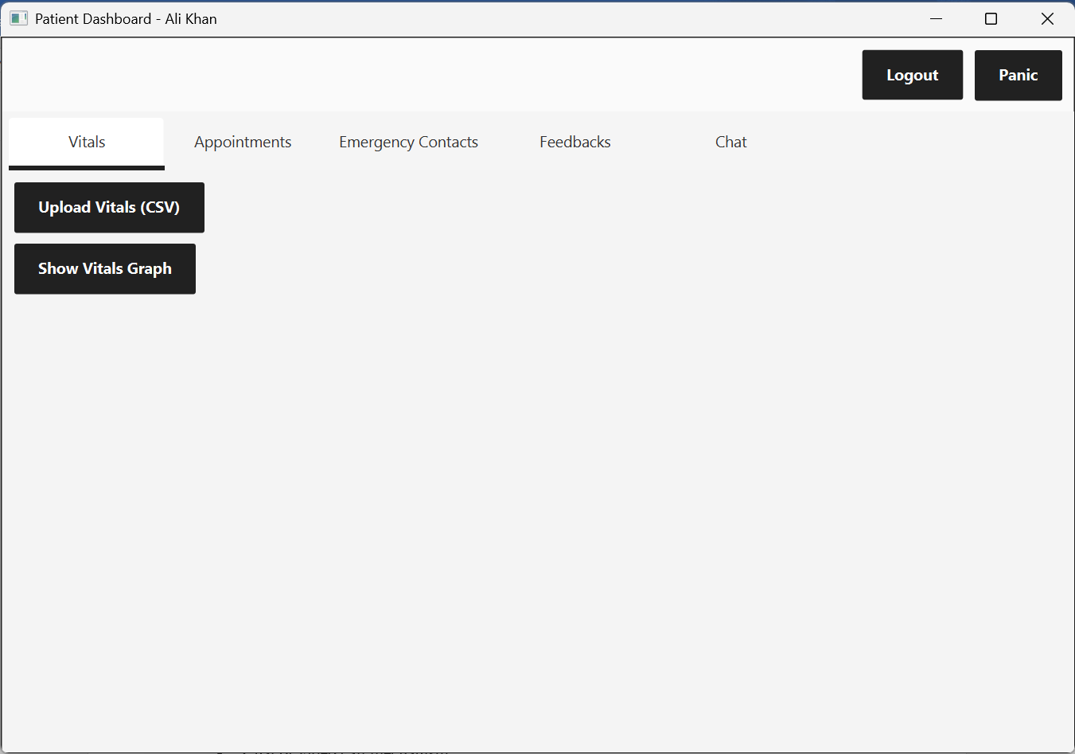

1. Click on the Upload Vitals (CSV) button

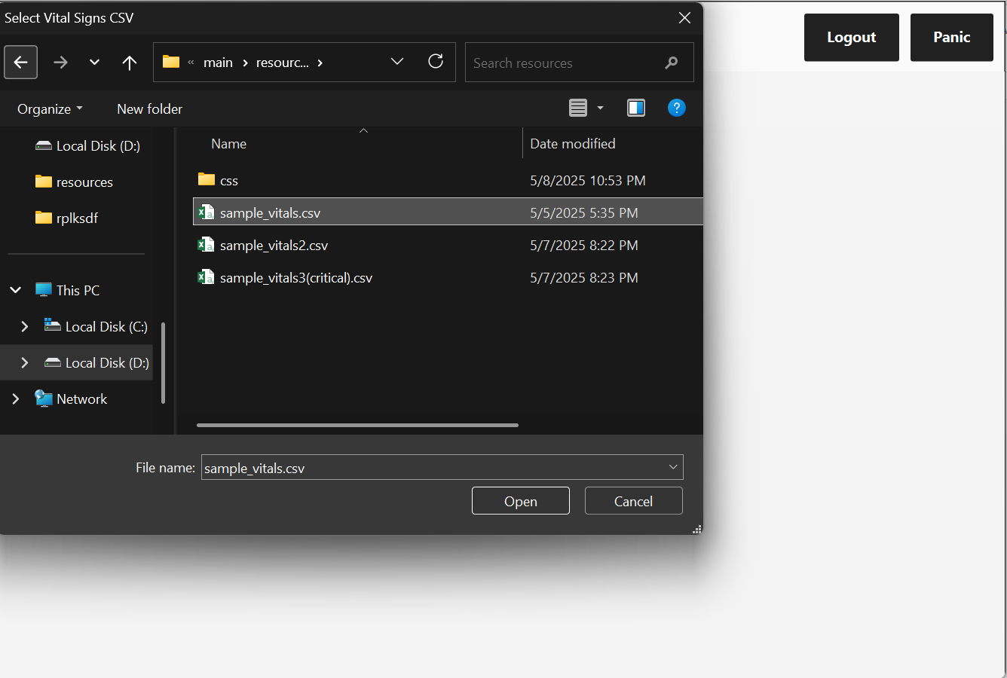

1. Select a valid csv file and upload it

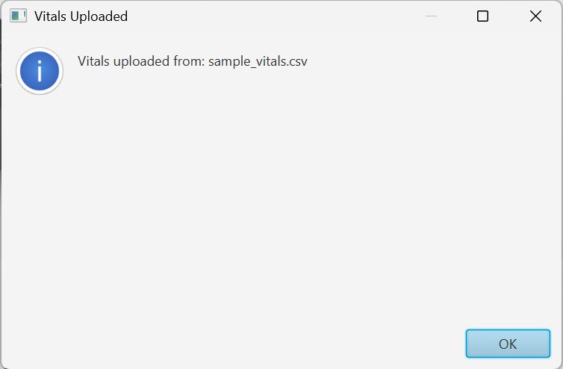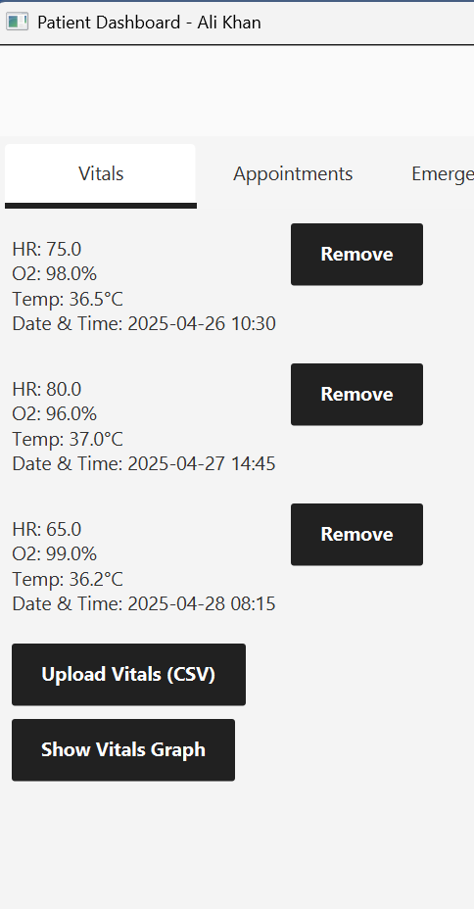

**2.3. Doctor-Patient Interaction**

* Viewing vitals, giving feedback, and prescribing medications/tests.

1. Viewing patient’s vitals:

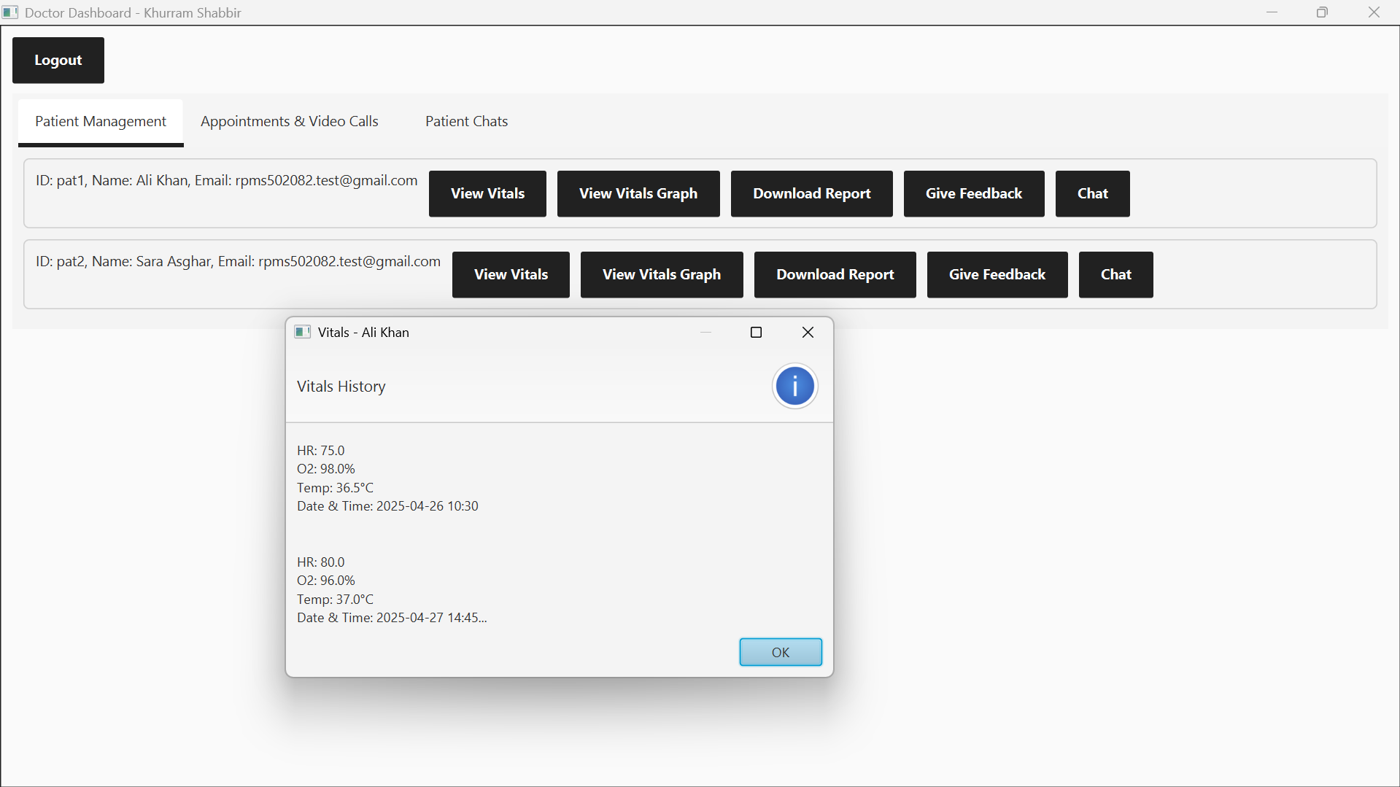

Click on the “view vitals” button to view the vitals.

1. Giving feedback and prescribing medicine

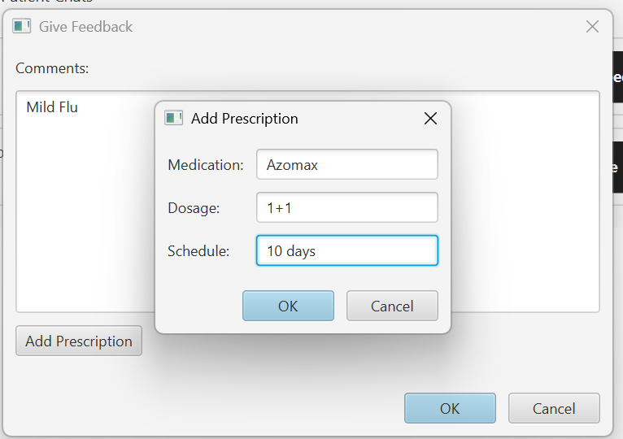

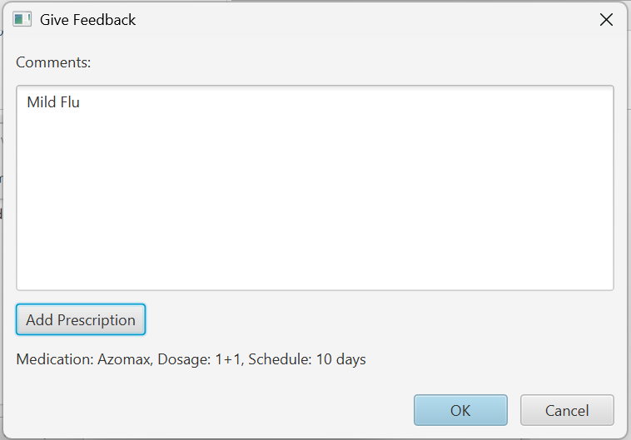

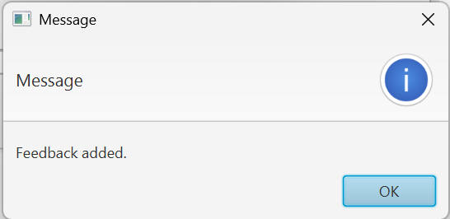

* Viewing history and feedback flow.

Past history will be displayed in a patient report

Click on the download report button and select a path to save the report as a text file.

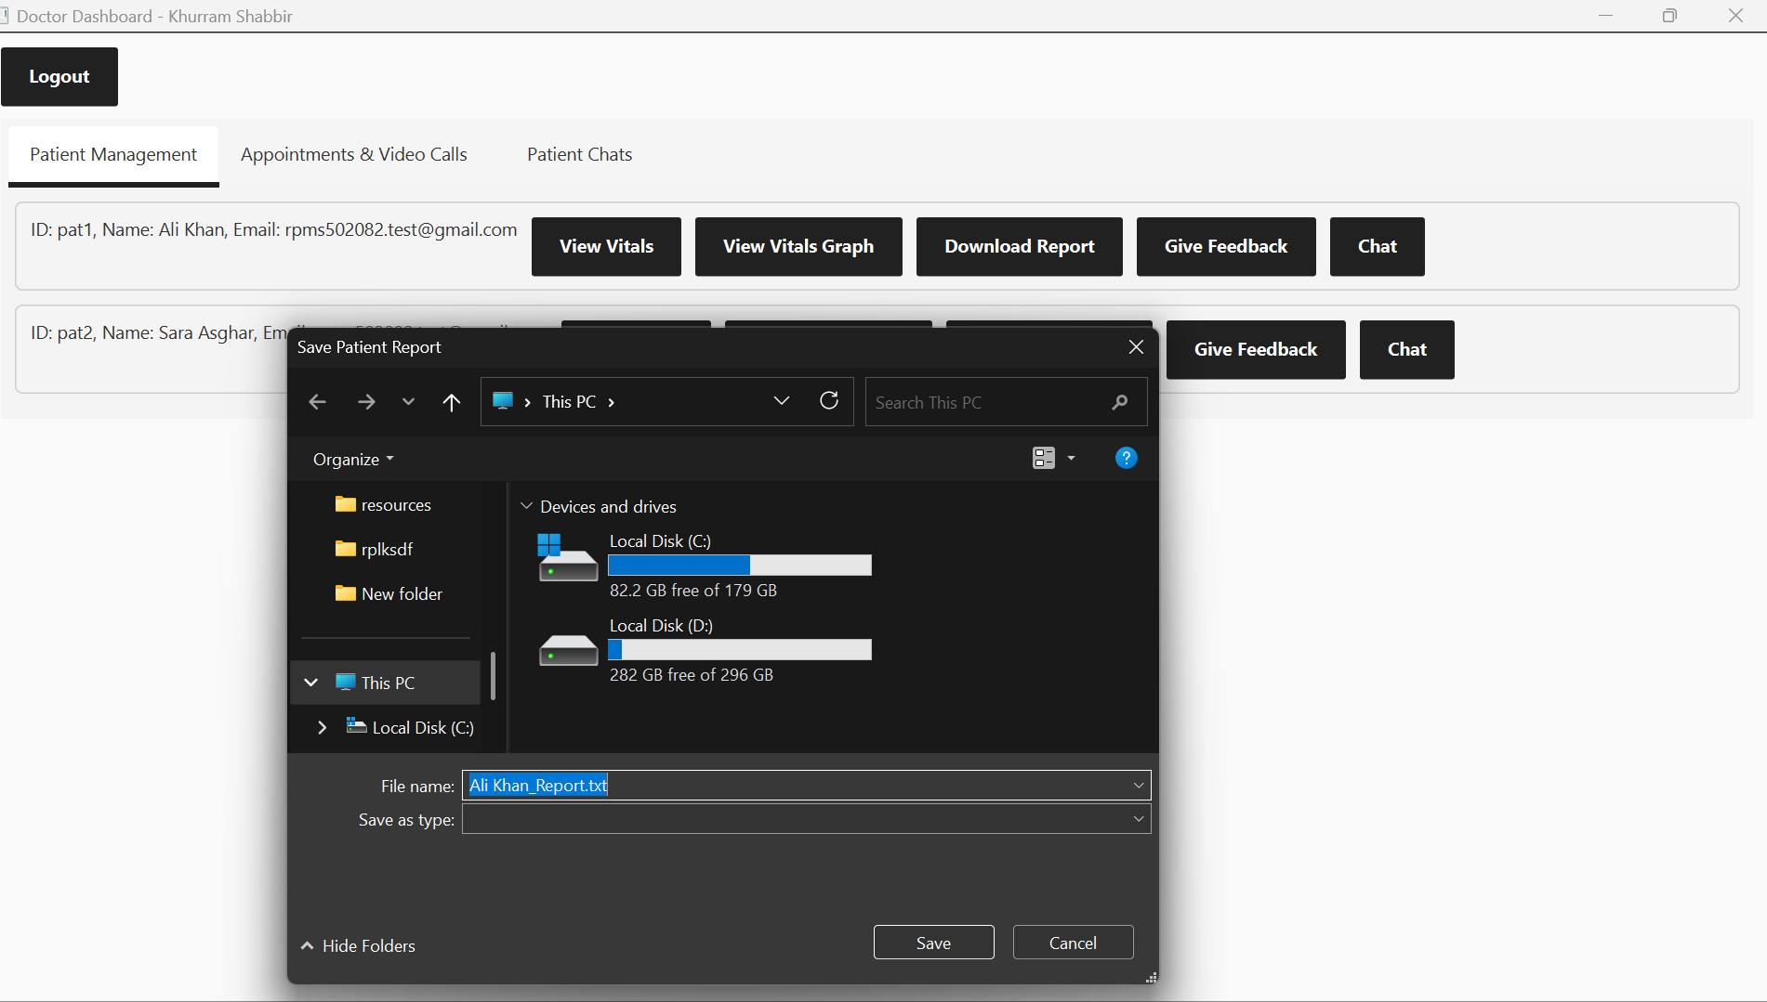

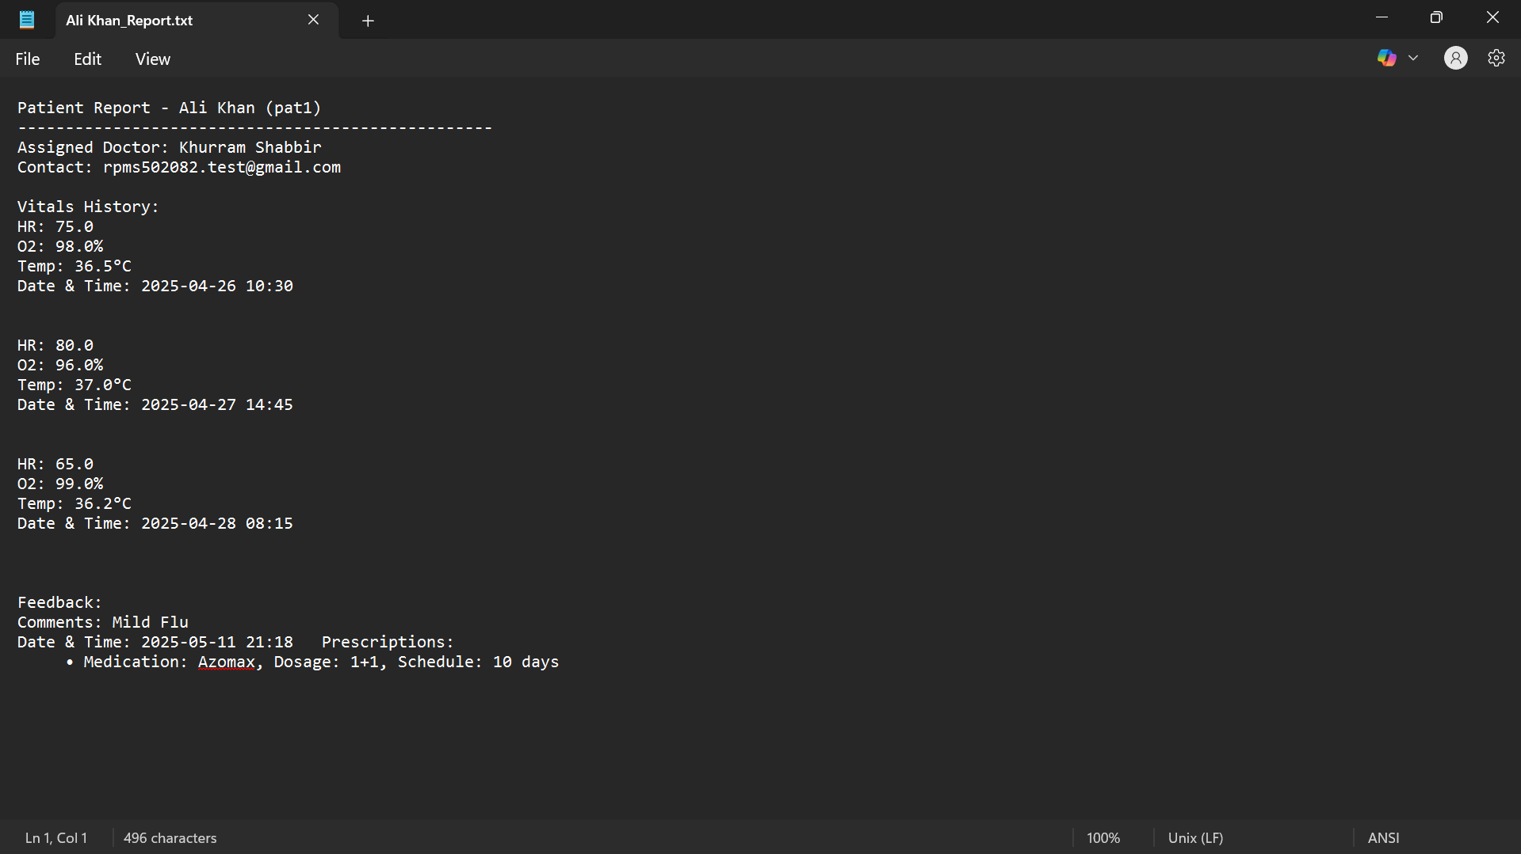

**2.4. Health Trends, Visualization & Report Generation**

* Vitals graphs generated.

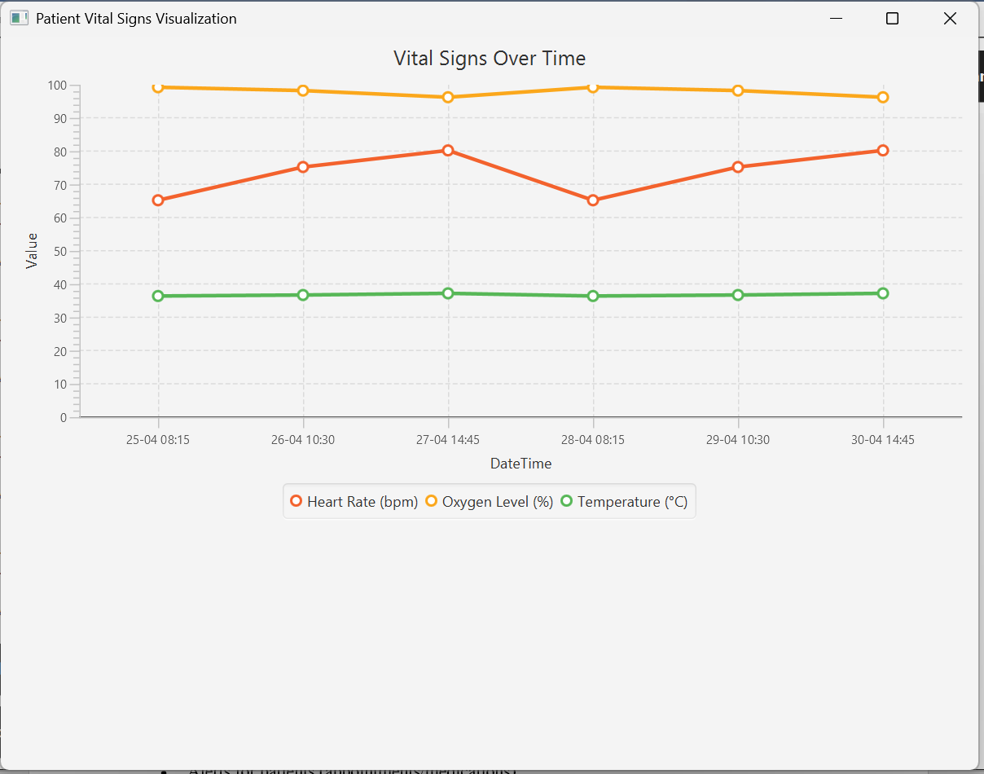

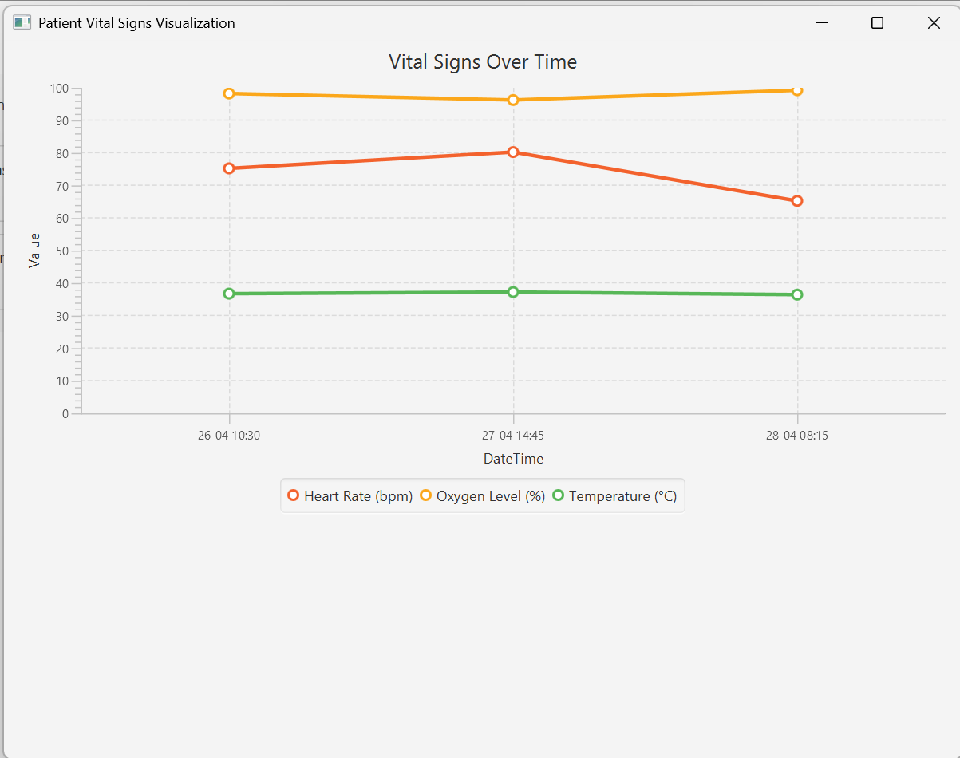

Both the patient and the doctor can view from their dashboards.

* Summary of downloadable health reports.



The Health report consists of Patient’s Information, Vitals History and Previous Feedbacks.

**2.5. Emergency Alert System**

* Automatic alerts on abnormal vitals.

Now, we will see what happens when a patient uploads critical vitals.

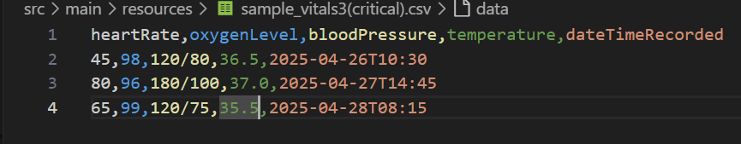

As we can see, this files consists of irregular/ critical vitals.

Let’s upload them now.

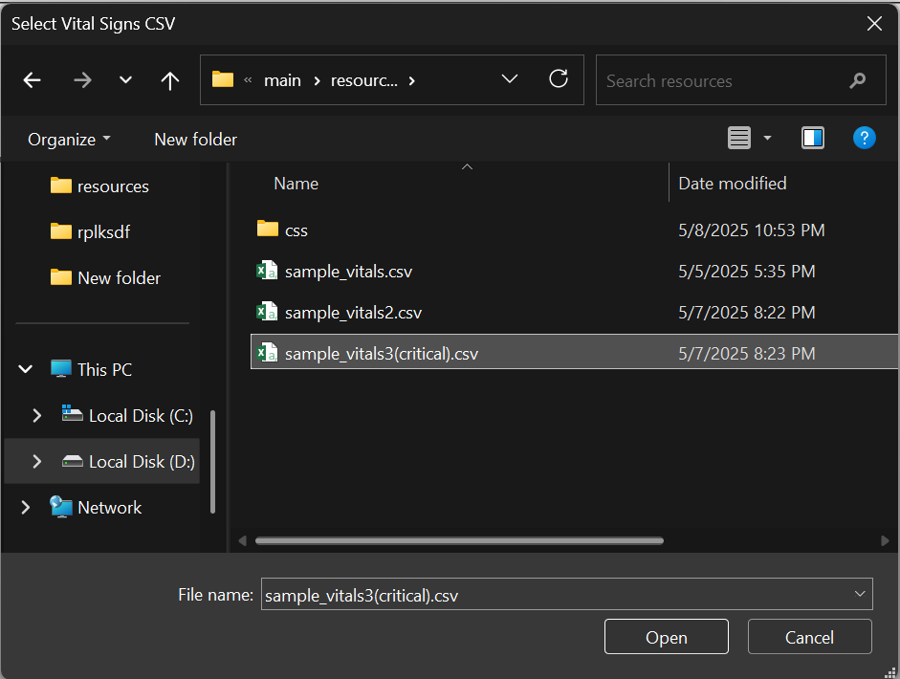

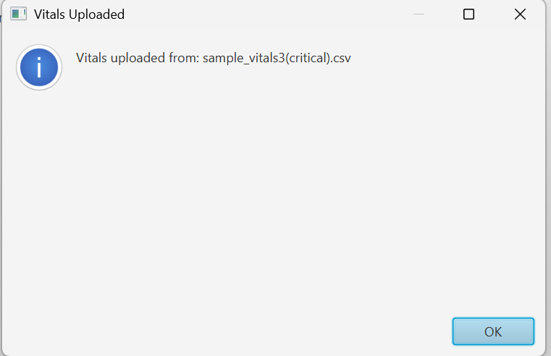

* 1. Patient receives alert:

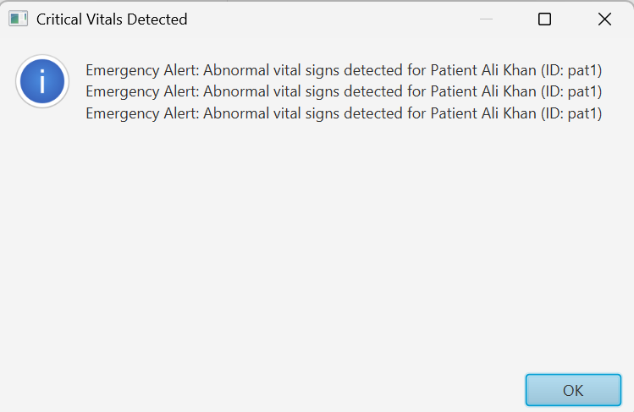

* 1. Email sent to emergency contacts of the patient and the assigned doctor (SMS not fully integrated)

NOTE: only 1 default email has been used in this project for testing purposes

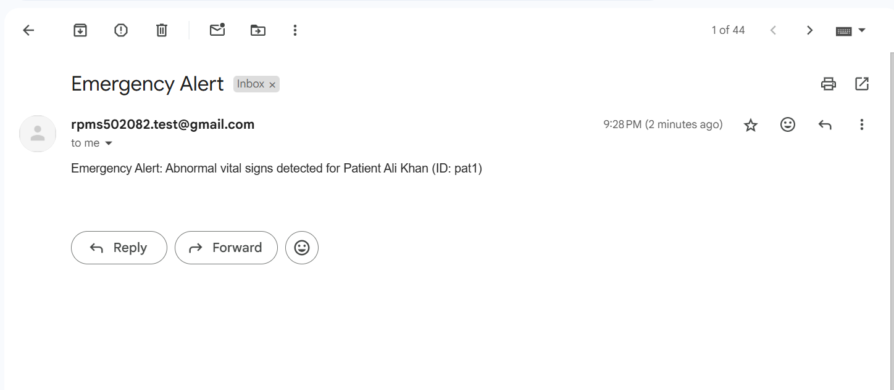

* 1. The assigned doctor (Physician) will receive an alert on their dashboards when they login.

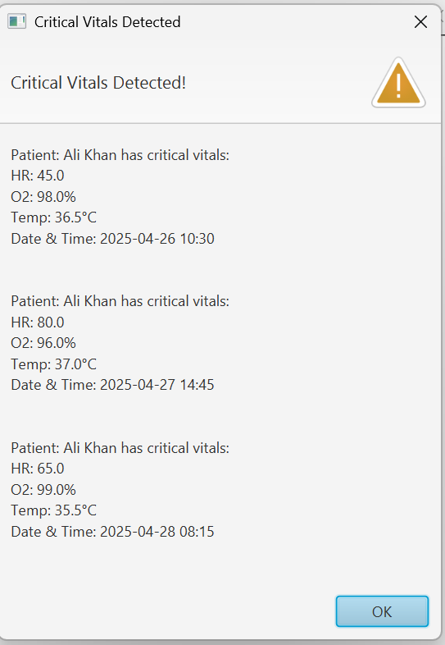

* Manual panic button and notification flow.

Patient has a panic button that they can press to enter a message to be sent to their emergency contacts and physician.

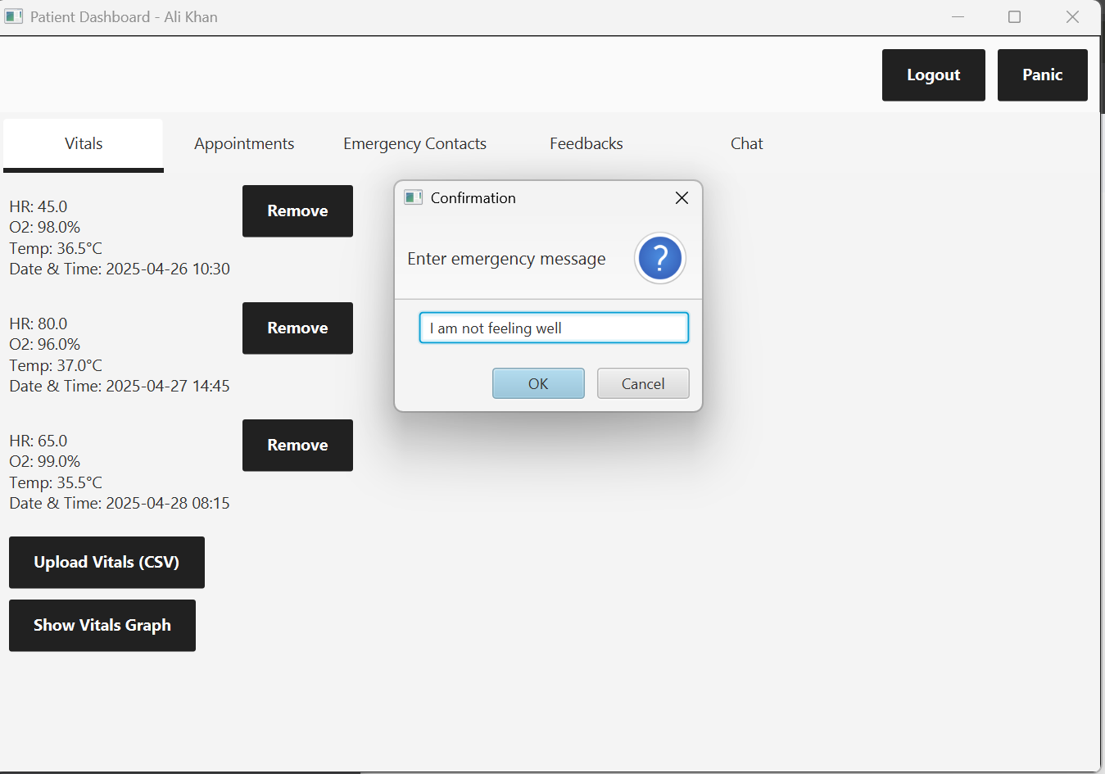

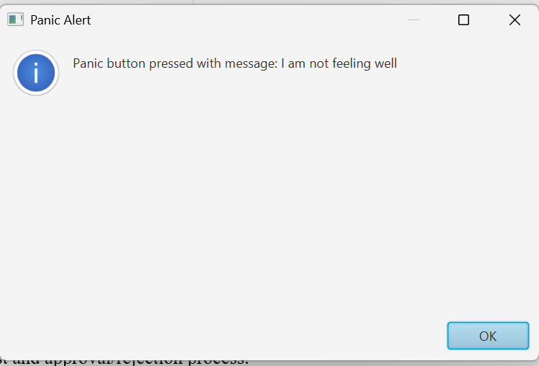

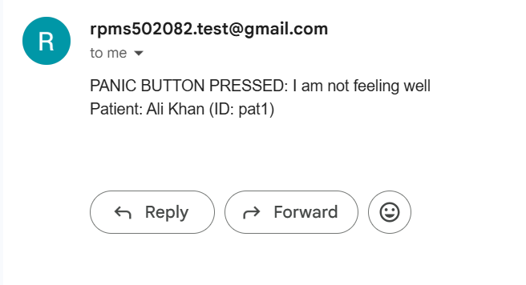

**2.6. Chat or Video Consultation**

* Chat or video call mechanism.

1. Video Call

Patient can request a video call. On approval, doctor has to provide a google meet link. This link can then be used to join the meeting on the scheduled time.

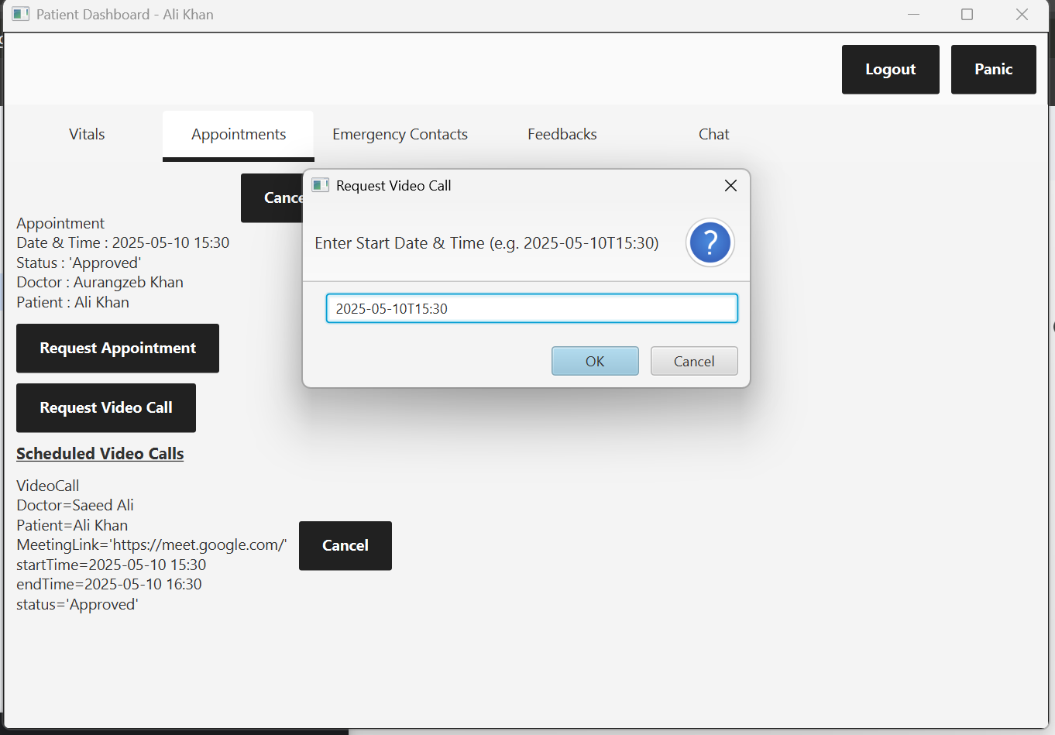

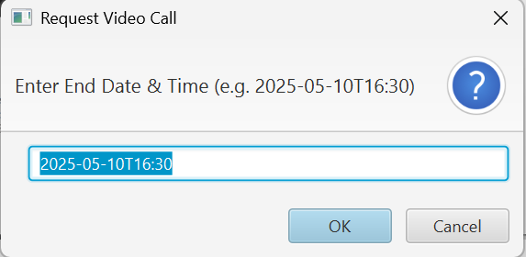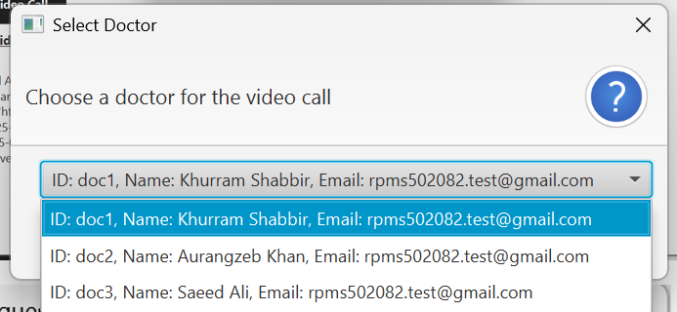

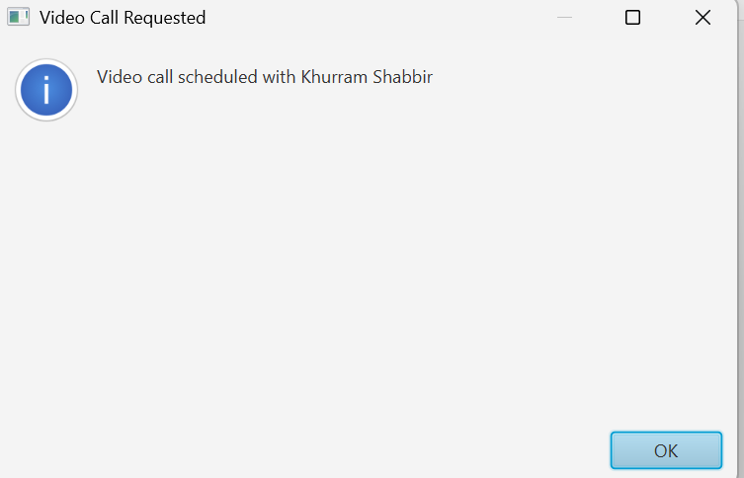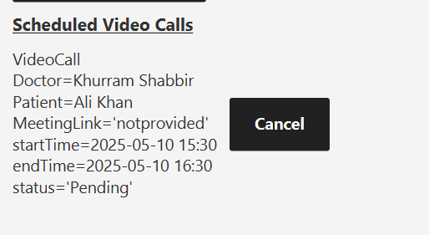

DOCTOR DASHBOARD NOW:  
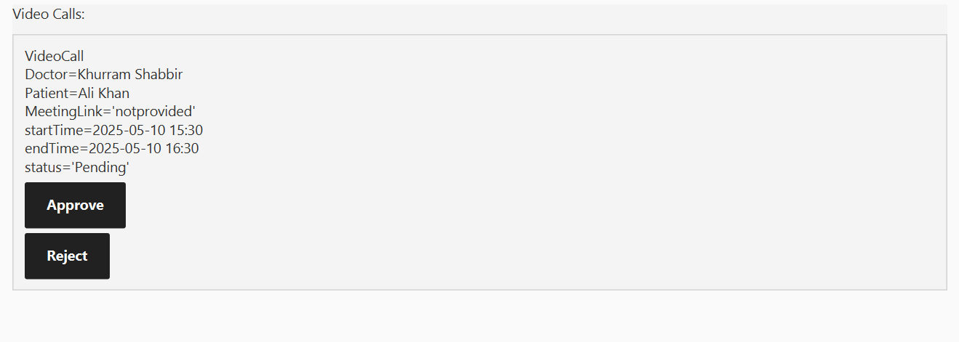

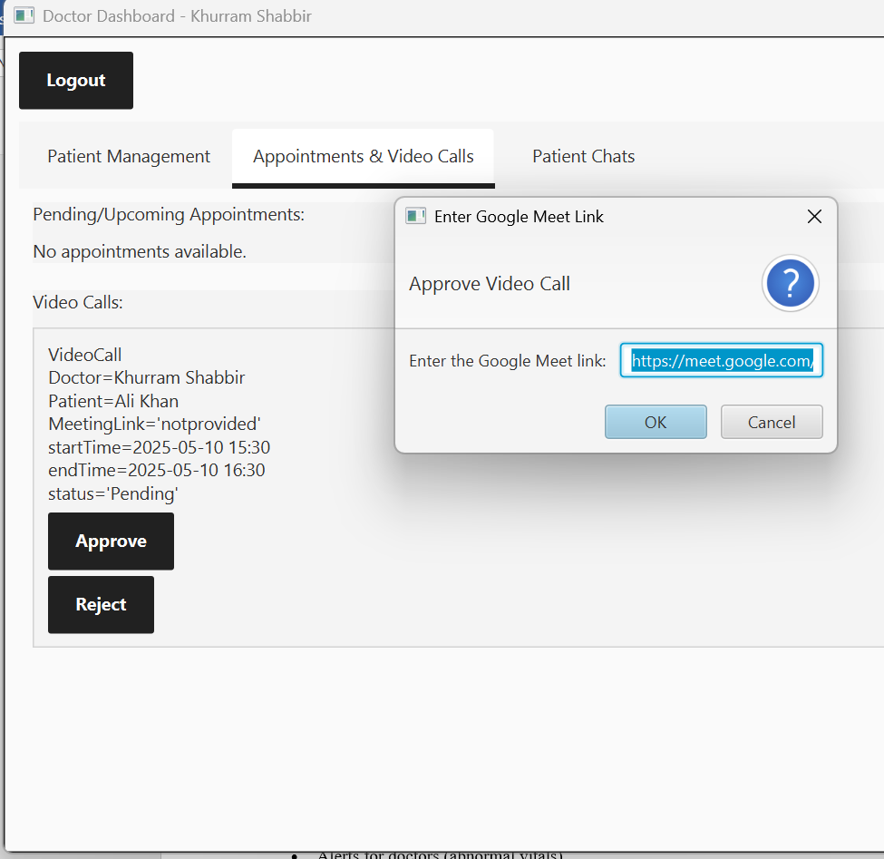

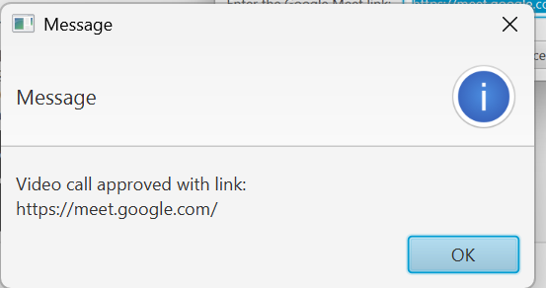.

Whenever a doctor approves an appointment, that specific patient is added to the list of patients for that doctor:

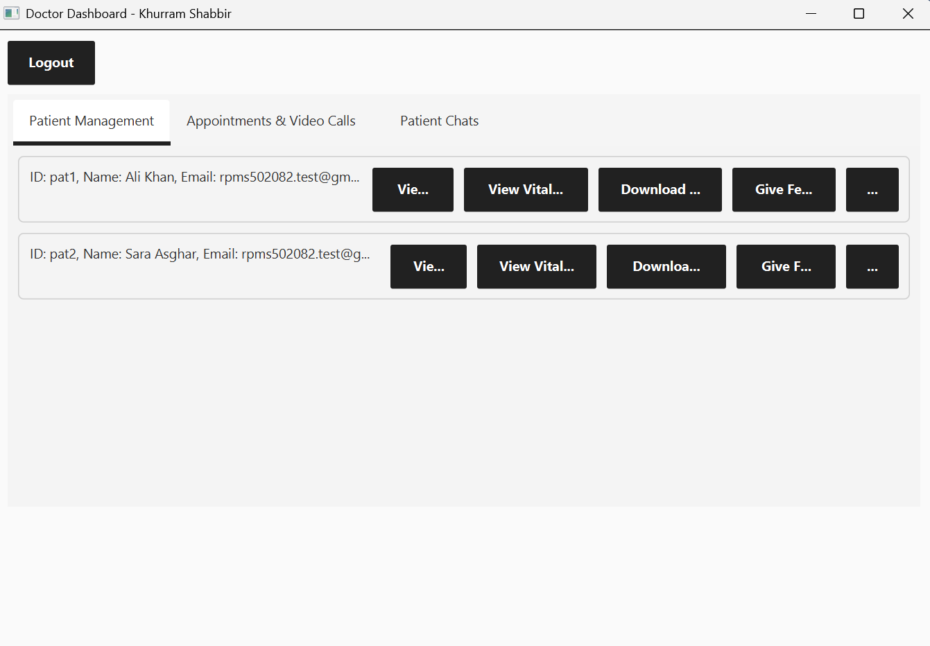

1. Chat Feature

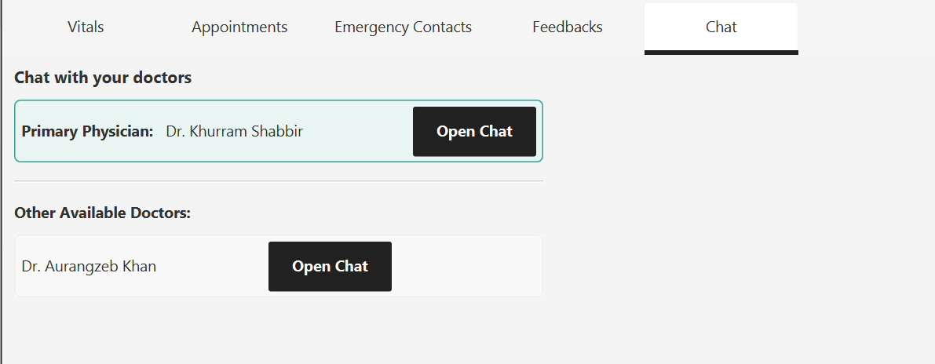

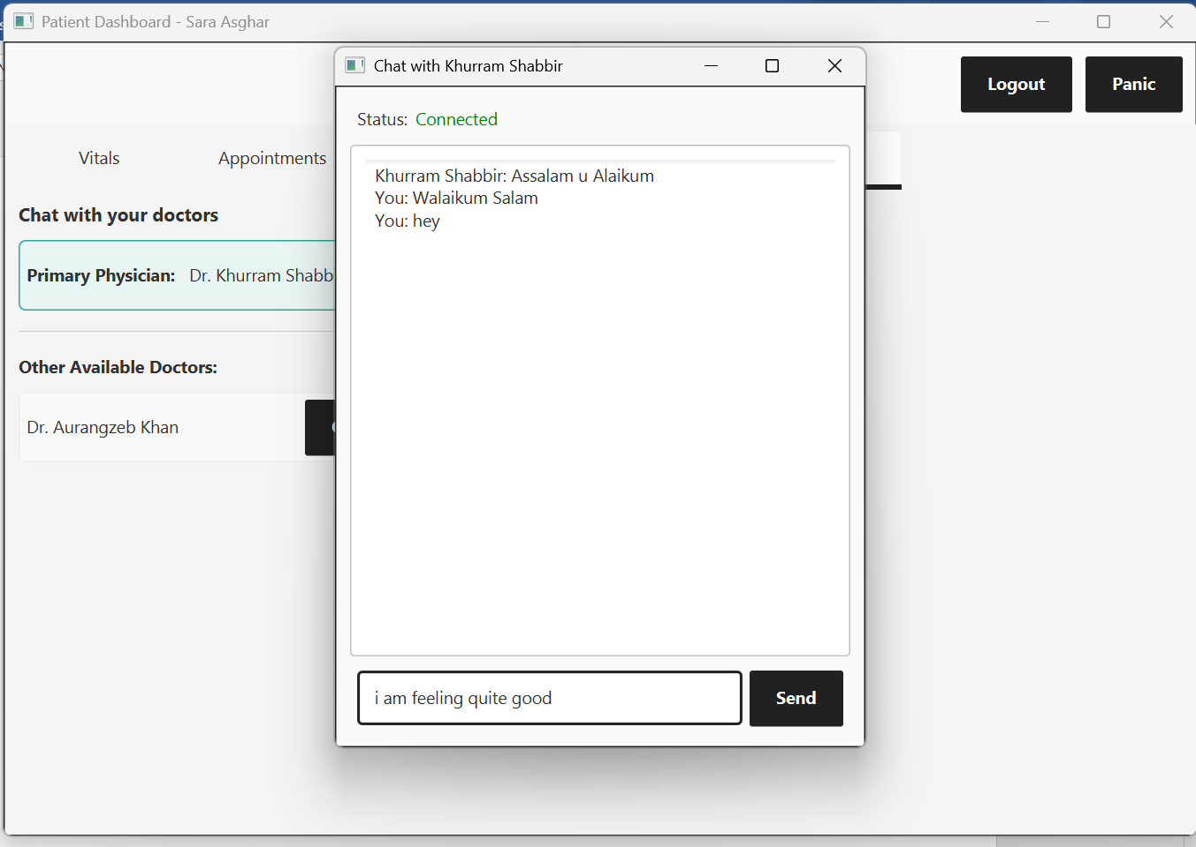

Now, the doctor’s point of view:

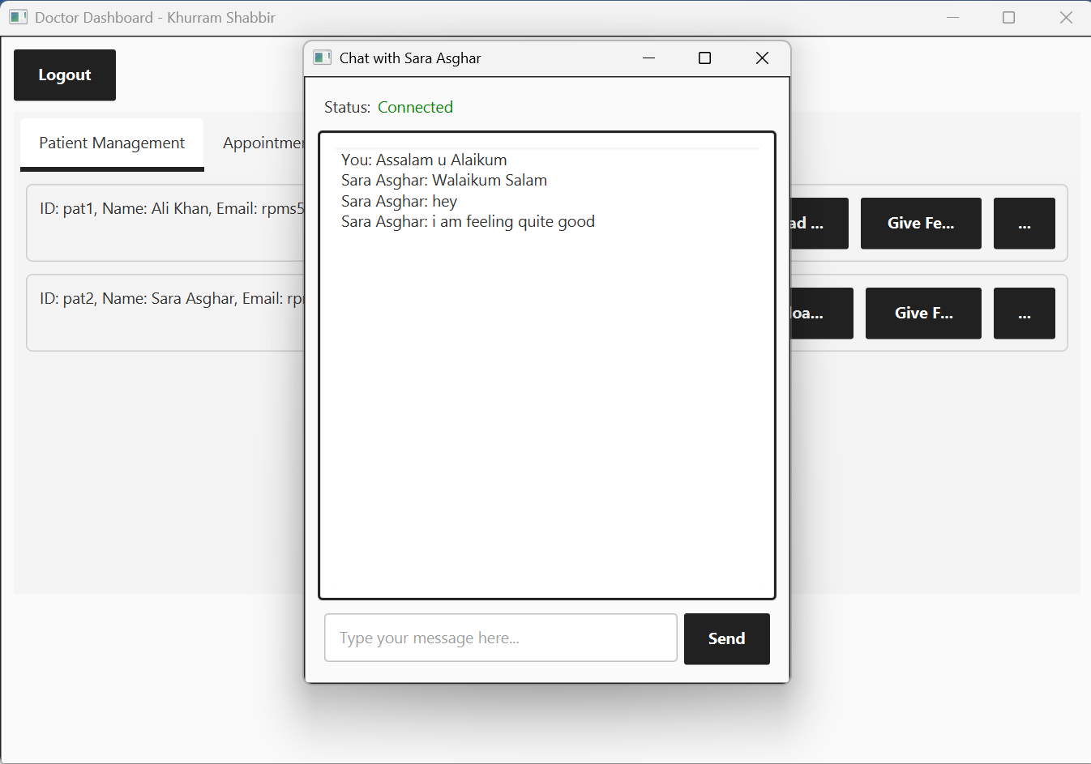

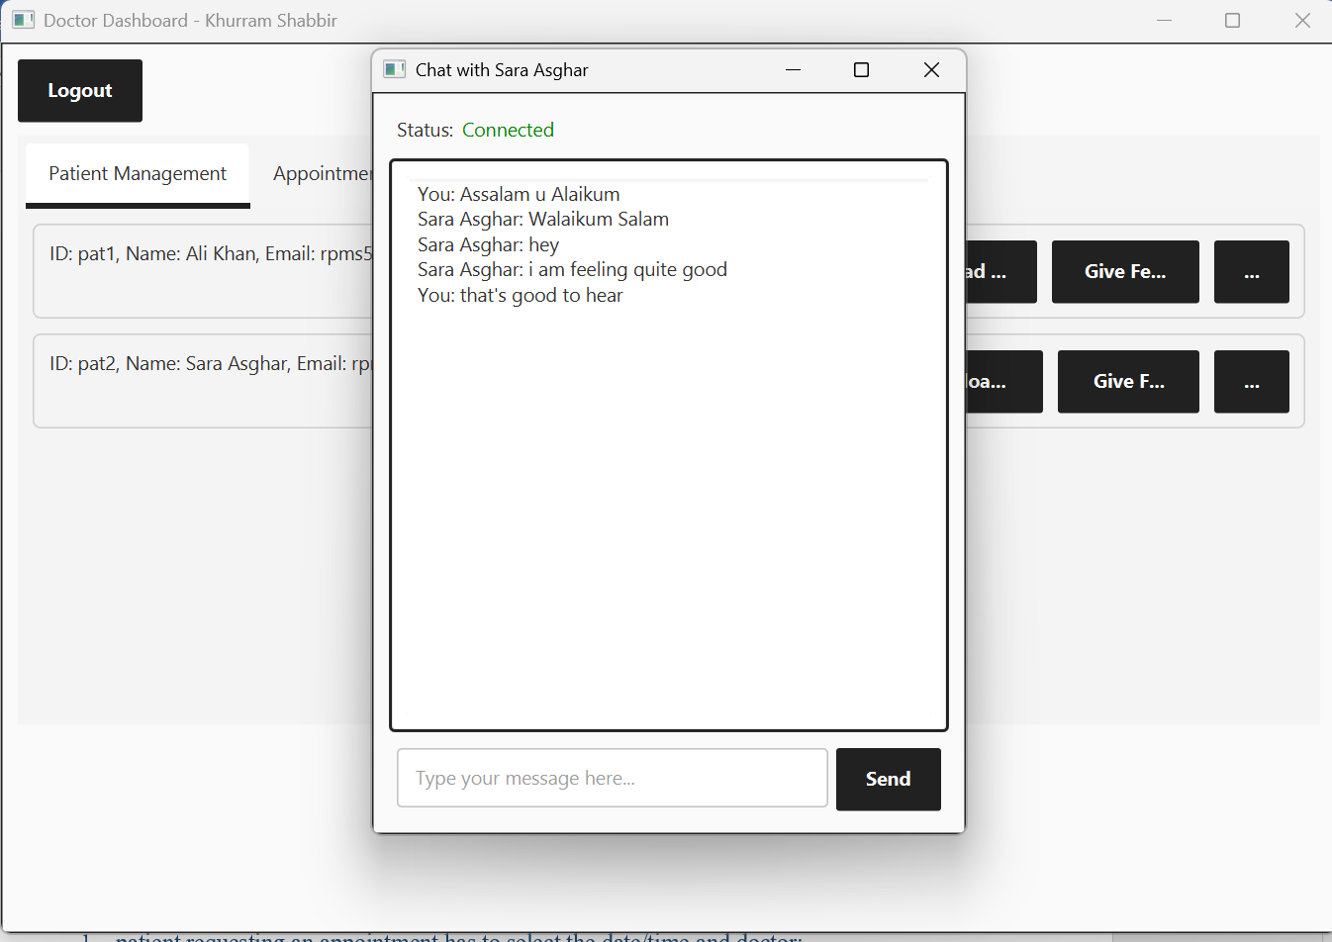

Chat Histories are also automatically loaded via object serialization.

**2.7. Appointment Scheduling**

* Request and approval/rejection process.
* Display of confirmed appointments.

The same procedure as video calls.

1. patient requesting an appointment has to select the date/time and doctor:  
   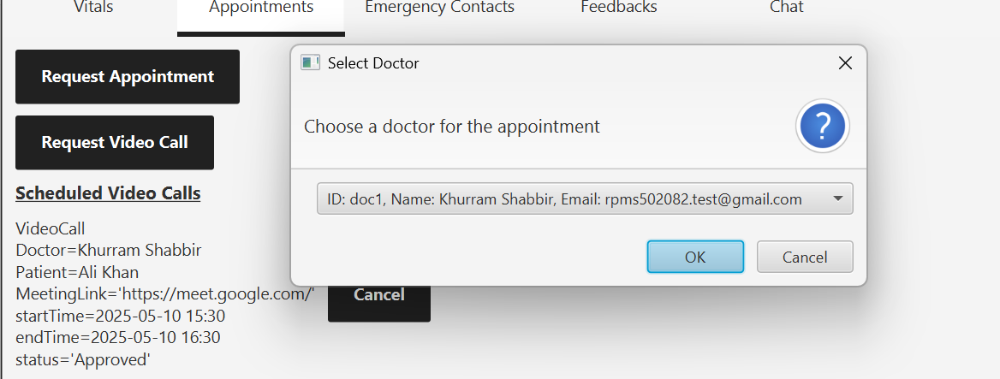

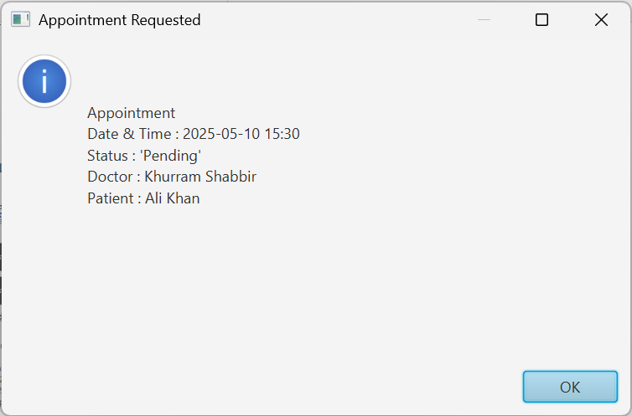

Doctor’s Dashboard:  
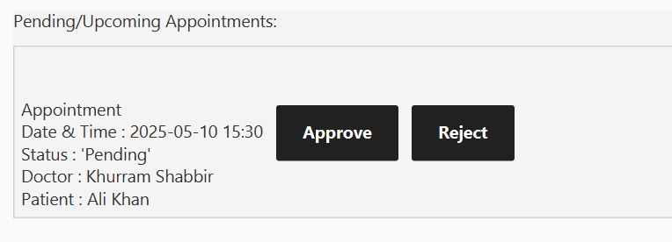

* 1. Approving

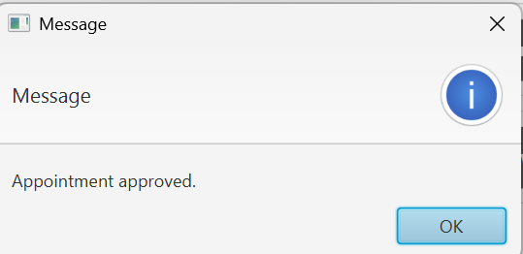

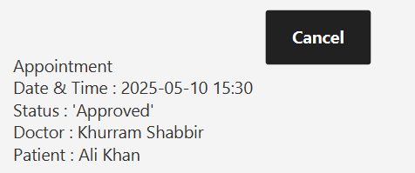

* 1. Rejecting

Either a patient can cancel an appointment or the doctor can reject/ cancel. In both cases, the appointment is removed from their tabs.

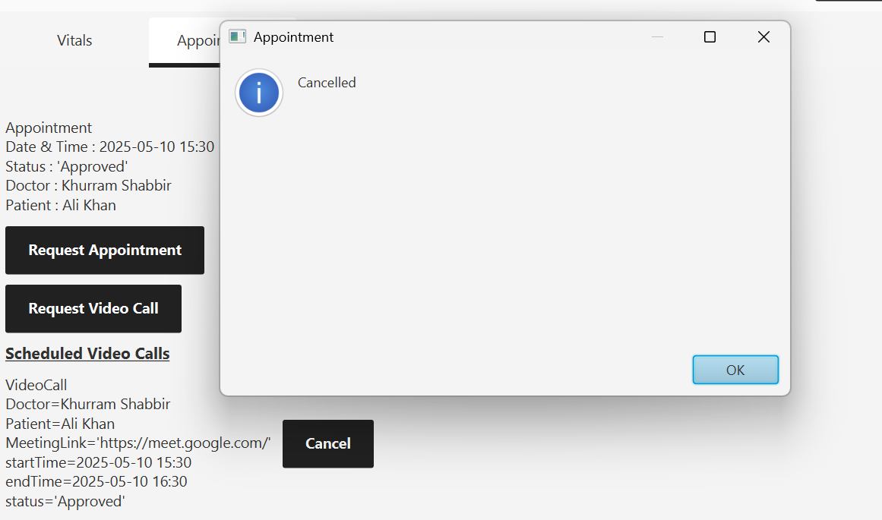

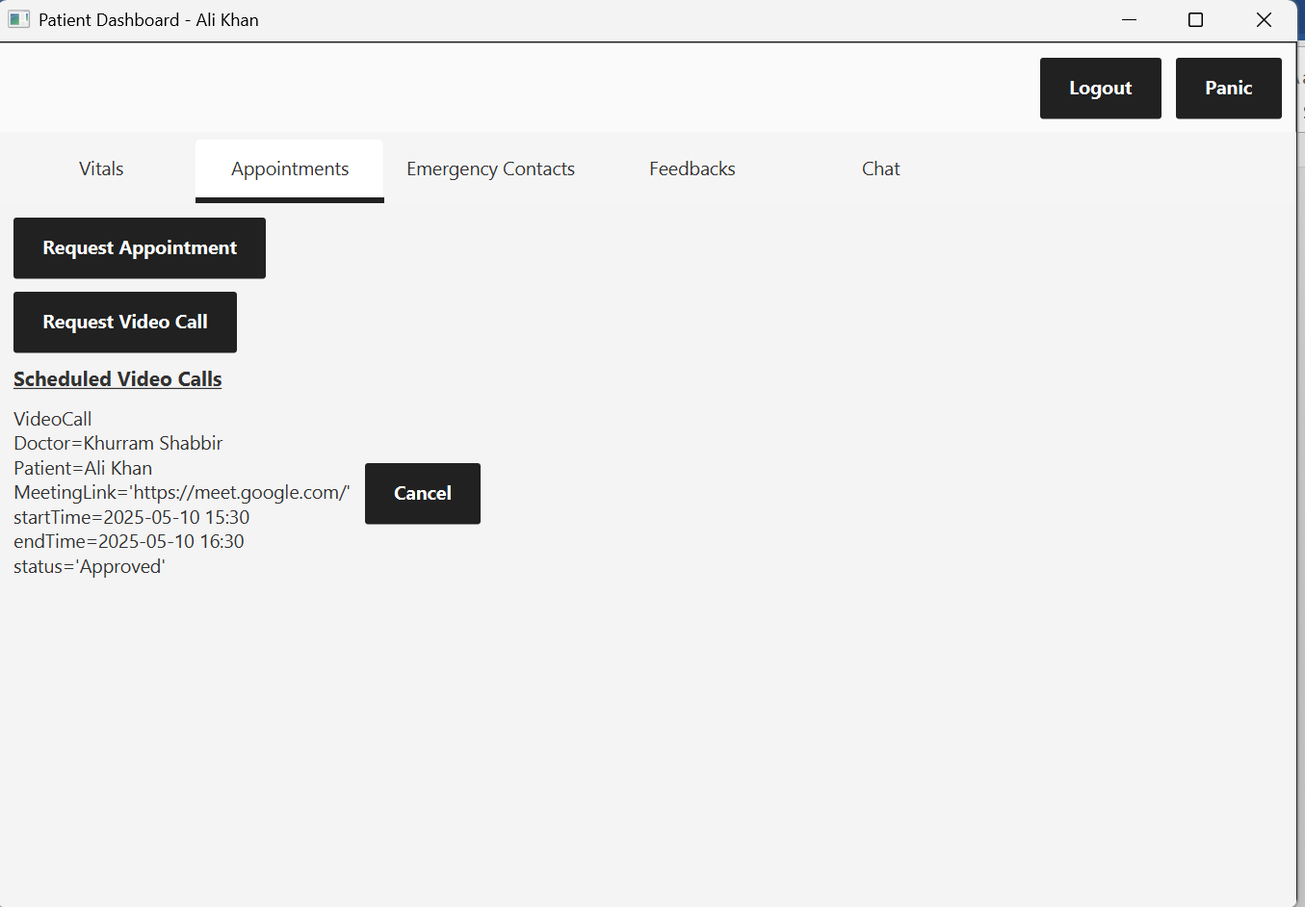

**2.8. Notifications & Reminders**

* Alerts for patients (medications).

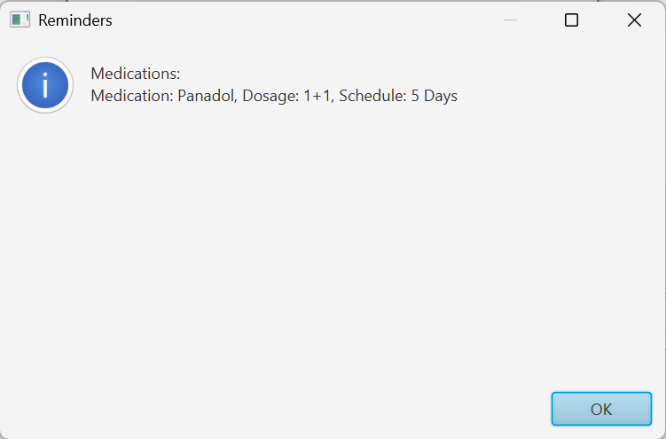

Patient receive medication and appointment reminders on dashboard and email whenever they login.

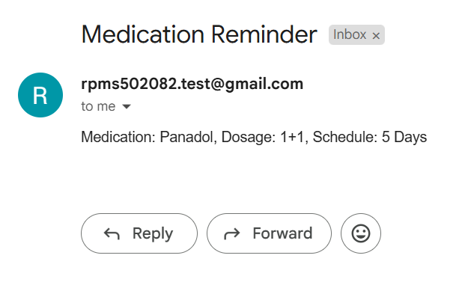

* Alerts for doctors (abnormal vitals).

Doctors will also receive alerts on dashboard and email.





**3. System Diagrams**

**3.1. UML Class Diagram**

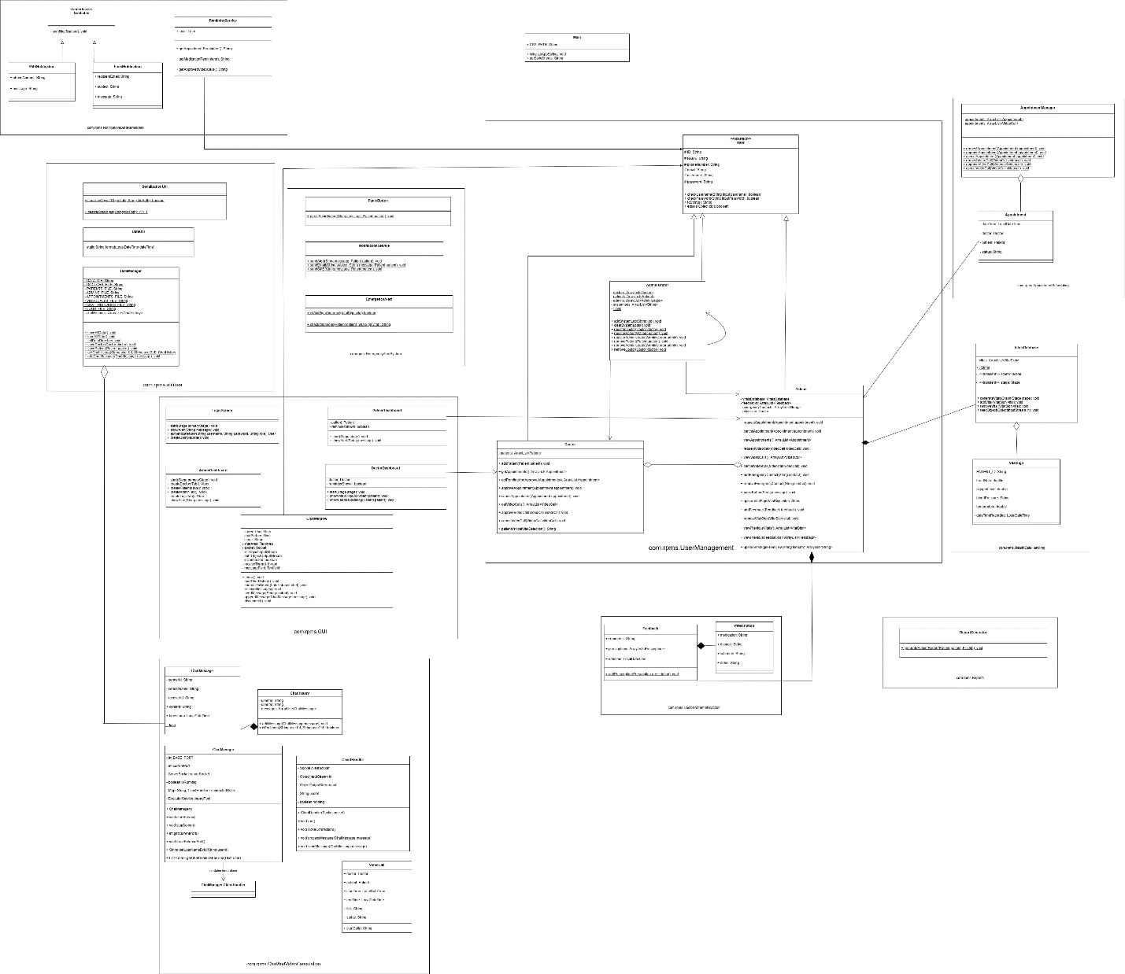

**NOTE: THE DIAGRAMS MIGHT NOT BE PROPERLY VISIBLE HERE. SO, to get a detailed view.**

* 1. **Go to draw.io**
  2. **Open the diagram provided in the root directory of the project.**

**5.2. System Flowchart**

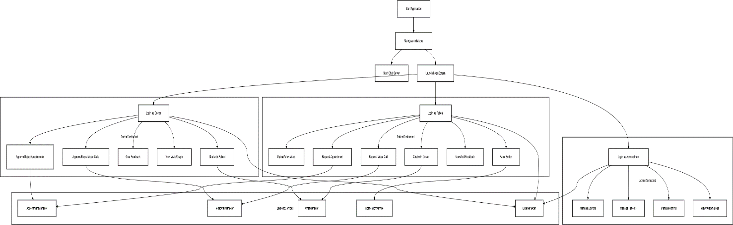

**4. Sample CSV files**

* Sample CSV file structure and sample content is provided in the following package:

“src/main/resources”